UNIVERSITY OF TORONTO
Department of Electrical and Computer Engineering
FIELD AND WAVES LABORATORY
Courses ECE 320F and ECE 357S
III Year
WAVES ON TRANSMISSION LINES
1. Object:
This is an investigation of the fundamental properties of travelling waves using a coaxial transmission line.
2. References:
- Your Lecture Notes.
- Ramo, Whinnery, Van Duzer, “Fields and Waves in Communication Electronics,” Chap. 5.
- Thomas, “Engineering Electromagnetics,” Chapter 11.
3. Travelling Waves:
The behaviour of plane electromagnetic waves in an unbounded lossless medium and transverse electromagnetic waves on lossless coaxial and parallel wire lines along the direction of propagation z can be characterized by a current i(t,z) and a voltage v(t,z) as shown in Fig. 1. For such waves, Maxwell’s equations reduce to the transmission line equations
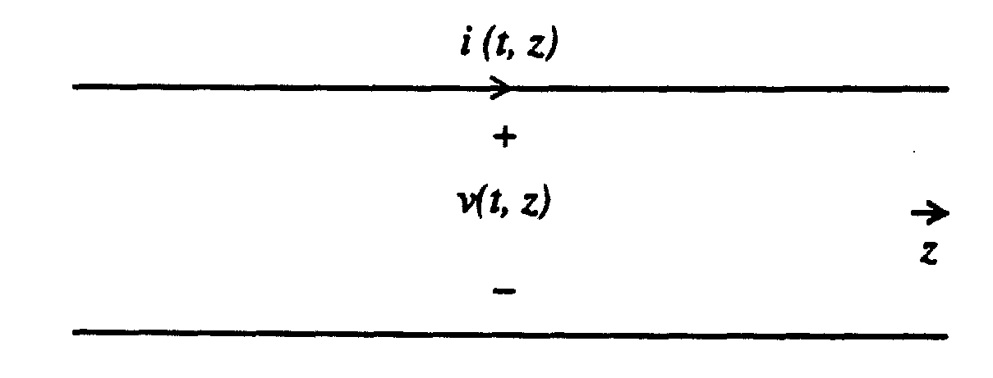
Fig. 1
$$\frac{∂v\left(t,z\right)}{∂z}=−ℓ\frac{∂i\left(t,z\right)}{∂t}$$
$$\frac{∂i\left(t,z\right)}{∂z}=−c\frac{∂v\left(t,z\right)}{∂t}$$
where $ℓ$ and c are respectively the inductance and capacitance per unit lengths of the line. Two possible solutions of these equations can be expressed in matrix form as follows:
$$\left[\begin{matrix}v_{1}\left(t,z\right) \\ i_{1}\left(t,z\right)\end{matrix}\right]=\left[\begin{matrix}1 \\ 1/Z_{0}\end{matrix}\right]f_{1}\left(t−z/u\right), \left[\begin{matrix}v_{2}\left(t,z\right) \\ i_{2}\left(t,z\right)\end{matrix}\right]\left[\begin{matrix}1 \\ −1/Z_{0}\end{matrix}\right]f_{2}\left(t+z/u\right)$$
where f1(z) and f2(z) are two arbitrary functions and
$$Z_{0}=\sqrt{\frac{ℓ}{c}},u=1/\frac{1}{\sqrt{ℓc}}$$
are the characteristic impedance and the velocity of propagation of the line. The general solution can be expressed as a superposition of these two solutions
$$\left[\begin{matrix}v\left(t,z\right) \\ i\left(t,z\right)\end{matrix}\right]=\left[\begin{matrix}v_{1}\left(t,z\right) \\ i_{1}\left(t,z\right)\end{matrix}\right]+\left[\begin{matrix}v_{2}\left(t,z\right) \\ i_{2}\left(t,z\right)\end{matrix}\right]$$
The solution
$$\left[\begin{matrix}v_{1}\left(t,z\right) \\ i_{1}\left(t,z\right)\end{matrix}\right]=\left[\begin{matrix}1 \\ 1/Z_{0}\end{matrix}\right]f_{1}\left(t−z/u\right)$$
has two important properties. First, the voltage and current waveforms are identical except for the constant Z0. Since we measure i in the +z direction, we find $v_{1}\left(t,z\right)/i_{1}\left(t,z\right)=Z_{0}$ for all t and z. This means looking in the +z direction, the transmission line behaves like a resistance equal to the characteristic impedance Z0. Secondly, the voltage and current are invariant along lines $t−z/u=\text{const}\text{.}$ As shown in Fig. 2a, points along such a line move with velocity u in the +z direction. The relation between $\left[\begin{matrix}v_{1} \\ i_{1}\end{matrix}\right]$at position z and that at the origin can be expressed as
$$\left[\begin{matrix}v_{1}\left(t,z\right) \\ i_{1}\left(t,z\right)\end{matrix}\right]=\left[\begin{matrix}v_{1}\left(t−z/u, 0\right) \\ i_{1}\left(t−z/u, 0\right)\end{matrix}\right]$$
As shown in Fig. 2b, a temporal waveform propagates with velocity u in the +z direction without change in shape. We therefore speak of this as a travelling wave in the +z direction. Since Z0 is positive real, we find $i_{1}\left(t,z\right)×v_{1}\left(t,z\right)>0$, i.e. there is power flow in the direction of propagation.
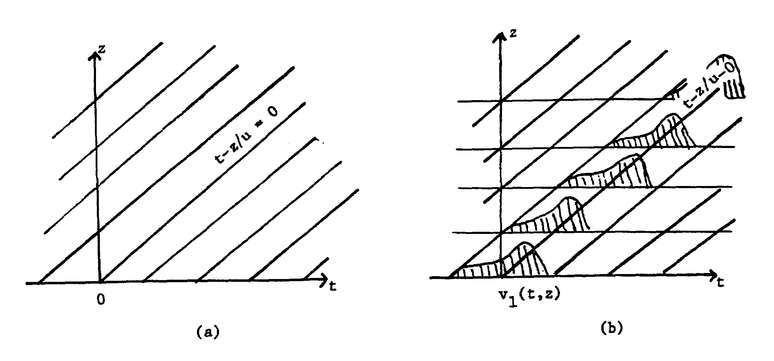
Fig. 2
The solution
$$\left[\begin{matrix}v_{2}\left(t,z\right) \\ i_{2}\left(t,z\right)\end{matrix}\right]=\left[\begin{matrix}1 \\ −1/Z_{0}\end{matrix}\right]f_{2}\left(t+z/u\right)$$
behaves in much the same way except that the ratio $v_{2}\left(t,z\right)/i_{2}\left(t,z\right)=−Z_{0}$ and that the solution is invariant along lines t + z/u = const. Since we measure current in +z direction, the first implies, if we look towards the -z direction, the line appears like a positive resistance of value Z₀. As shown in Fig. 3, points along such lines move with velocity u in the -z direction and that the waveform will also propagate in the -z direction without change
$$\left[\begin{matrix}v_{2}\left(t,0\right) \\ i_{2}\left(t,0\right)\end{matrix}\right]=\left[\begin{matrix}v_{2}\left(t−z/u,z\right) \\ i_{2}\left(t−z/u,z\right)\end{matrix}\right]$$
The power flow is in the -z direction since $−i_{2}\left(t,z\right)v_{2}\left(t,z\right)>0\text{.}$ Such a solution is a travelling wave in the -z direction.
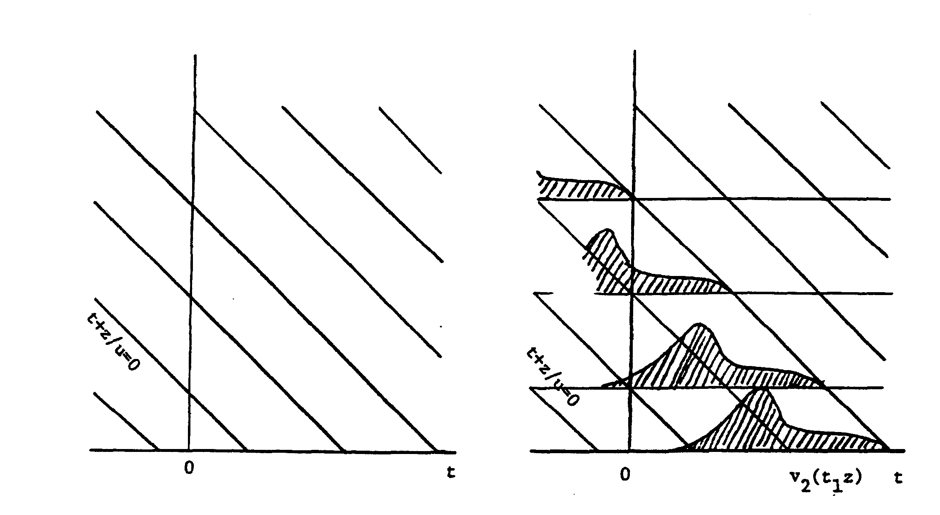
(a) Fig. 3 (b)
4. Excitation of Travelling Waves:
To excite travelling waves, let us look at a few examples.
In Fig. 4a a voltage source generating a known voltage waveform Vs(t) is used to excite an infinitely long line at z = 0. Since power can only be supplied by the generator to the line, therefore we can only have power flow away from the generator. As a result, to the right there is a +z travelling wave while to the left there is a -z travelling wave, i.e.
$$\left[\begin{matrix}\left[v\left(t,z\right)\right] \\ \left[i\left(t,z\right)\right]\end{matrix}\right]=\left\{\begin{matrix}\left[\begin{matrix}v_{1}\left(t,z\right) \\ i_{1}\left(t,z\right)\end{matrix}\right]z>0 \\ \left[\begin{matrix}v_{2}\left(t,z\right) \\ i_{2}\left(t,z\right)\end{matrix}\right]z>0\end{matrix}\right.$$
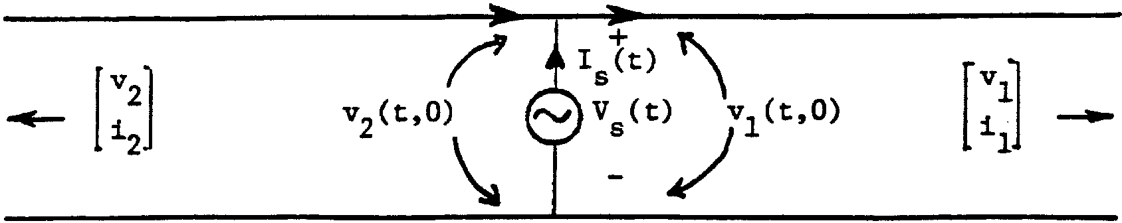
line z=0 line
(a)
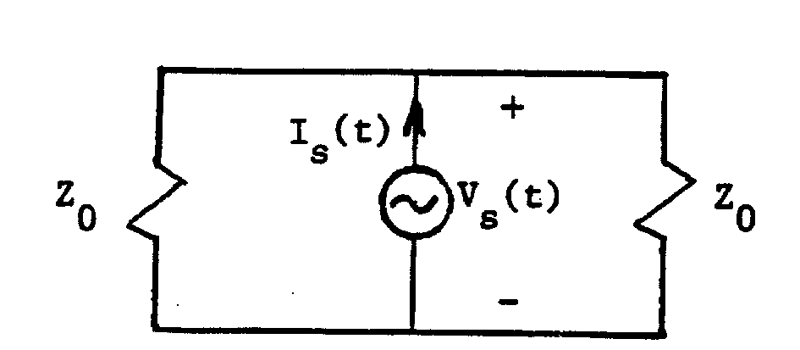
(b)
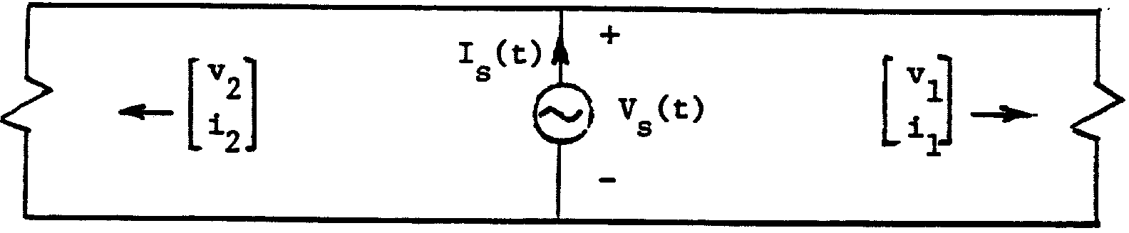
line (c) line
Fig. 4
At z = 0 the voltage across the line is equal to the voltage source voltage, the voltage slightly to the right and the voltage slightly to the left. Hence
$V_{s}(t)={\text{ v}}_{1}(\text{t,}0)={\text{ v}}_{2}(t,0)$.
The current supplied by the source must, however, be the sum of the currents going to the two sides, i.e.
$$I_{s}\left(t\right)=i_{1}\left(t,0\right)−i_{2}\left(t,0\right)\text{.}$$
The negative sign appears in i₂ (t, 0) because it is measured in the +z direction. The above two relations are known as boundary conditions which enable us to determine uniquely the voltage and current on the line. The first determines the two waves excited on the two sides, i.e.
$\left[\begin{matrix}v\left(t,z\right) \\ i\left(t,z\right)\end{matrix}\right]=\left\{\begin{matrix}\left[\begin{matrix}1 \\ 1/Z_{0}\end{matrix}\right]V_{s}\left(t−z/u\right)z<0 \\ \left[\begin{matrix}1 \\ −1/Z_{0}\end{matrix}\right]V_{x}\left(t+z/u\right)z<0\end{matrix}\right.$.
From these values of current waves the second boundary condition yields the source current
$I_{s}\left(t\right)=\left(\frac{1}{Z_{0}}−\frac{1}{−Z_{0}}\right)V_{s}\left(t\right)=\frac{2}{Z_{0}}V_{s}\left(t\right)$.
We observe that, as far as the source is concerned, the semi-infinitely long transmission on each side of the source can be replaced by a resistor equal to the characteristic impedance of the line (Fig. 4b).
In reality, only lines of finite length exist. Is there some way that can cut off the line on the two sides such that on the portion that remains the voltage and current behave in the same manner as on the infinite line that we discussed before? The answer is “yes” because only one travelling wave exists on each side. As previously shown, for each travelling wave the line looks like a resistor equal to $Z_{0}$ without changing the voltage and current distribution in the remaining portion (Fig. 4c). Such terminations are known as matched to the line. With termination resistance other than $Z_{0}$, Ohm’s law cannot be satisfied by the voltage and current associated with one travelling wave. As a result, a wave in the opposite direction is generated at the termination. This reflection phenomenon will be studied in detail in the next experiment.
Finally, the two sides of the transmission of Fig. 4c can be considered as two lines in parallel. Thus it is only necessary to investigate one of the sides as in Fig. 5. Note here we have added a resistor in series with the voltage source to facilitate the measurement of source current. This is the configuration to be studied in the experiment.
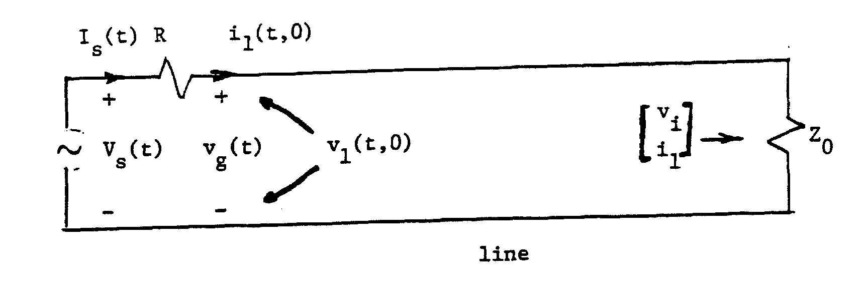
Fig. 5
5. Frequency Domain Analysis of Travelling Waves:
Let the source waveform be sinusoidal such that $V_{s}\left(t\right)=\text{Re}\left\{V_{s}e^{jωt}\right\}$. The voltage and current on the matched transmission line of Fig. 5 can be obtained by replacing t by $t−z/u$, i.e.
$$\begin{aligned}\left[\begin{matrix}v_{1}\left(t,z\right) \\ i_{1}\left(t,z\right)\end{matrix}\right]=\text{Re}\left\{V_{s}\left[\begin{matrix}1 \\ Z_{0}\end{matrix}\right]e^{j\left[ω\left(t−z/u\right)\right]}\right\} \\ \text{Re}\left\{V_{s}\left[\begin{matrix}1 \\ Z_{0}\end{matrix}\right]e^{j\left[ωt−βz\right]}\right\}\end{aligned}$$
where
$$β=ω/u$$
For every position the temporal waveform is a sine wave with angular frequency β and period $T=2π/ω$. For every time the spatial waveform is again sinusoidal with spatial angular frequency β and spatial period of wavelength $λ=2π/ω$; β is also known as the propagation constant. Lines in t, z plane where $t−z/u$= constant represent lines of constant phase for the sine wave (Fig. 6). At position z the phase is delayed with respect to that at position 0 by $z=\frac{z}{u}$ which is a linear function of frequency. The velocity u corresponding to these lines is therefore also referred to as phase velocity. In media with dispersion where distortion accompanies propagation, velocity of propagation no longer has precise meaning. However, sine waves will always remain sine waves, hence phase velocity retains its physical significance. One final relation between various quantities is
$$λ=\frac{2π}{β}=2π\frac{u}{ω}=\frac{u}{f}=\text{Tu}$$
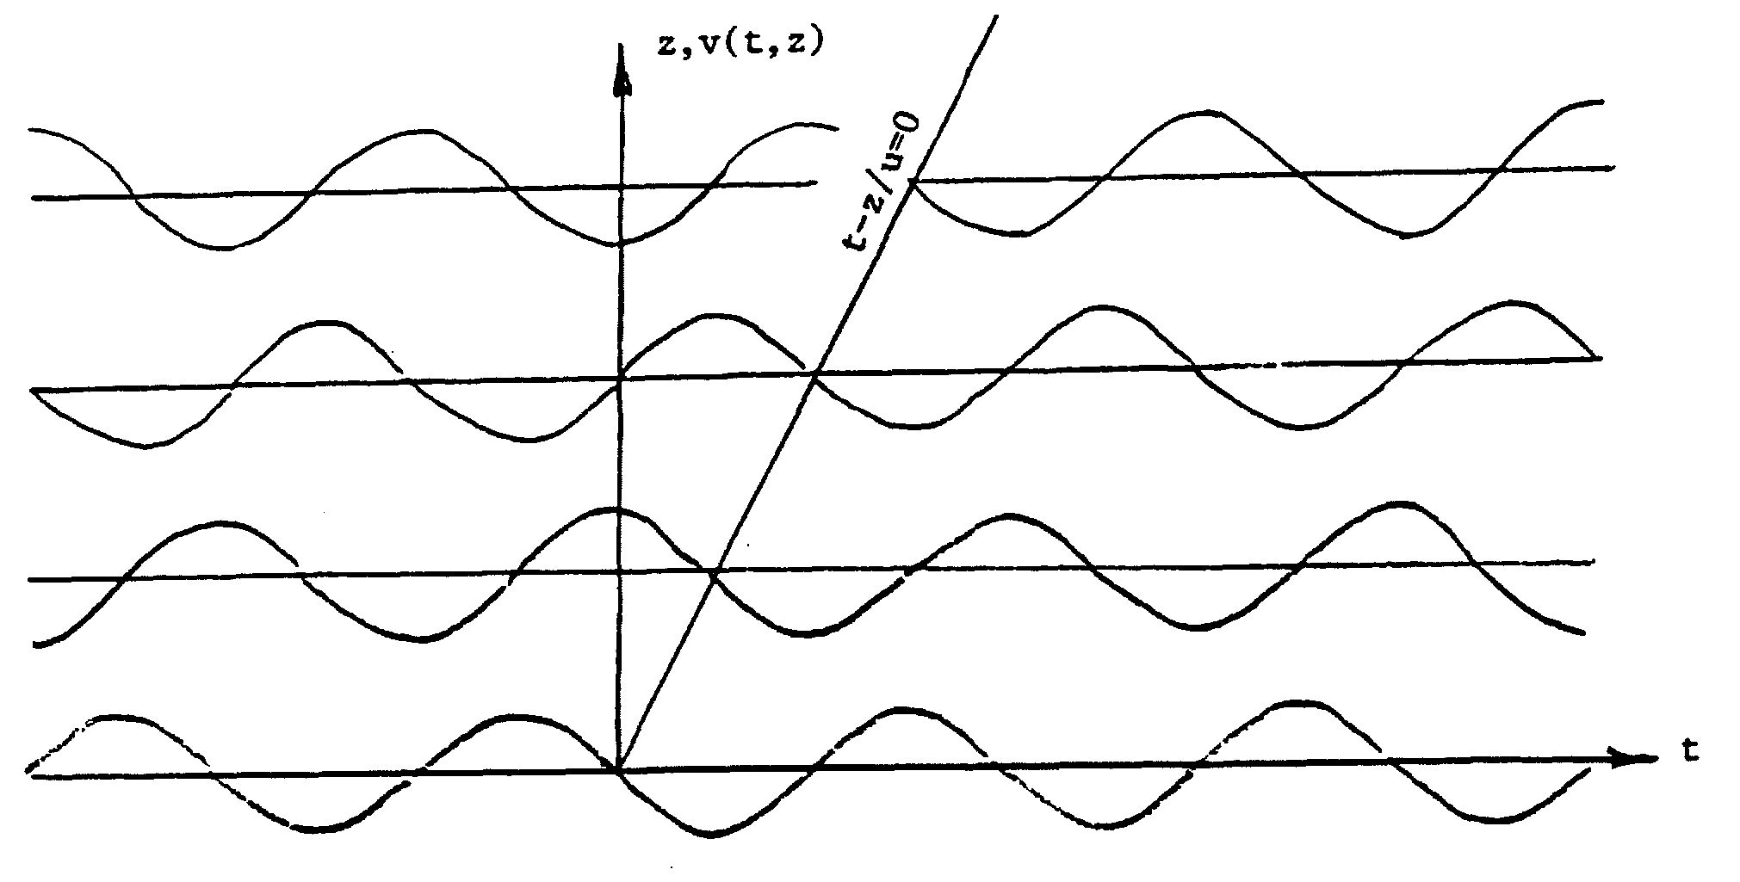
Fig. 6
For an arbitrary waveform, by means of Fourier integral representation, it is easily seen that
$$\left[\begin{matrix}v_{1}\left(t,z\right) \\ i_{1}\left(t,z\right)\end{matrix}\right]=\text{Re}\left\{\left[\begin{matrix}1 \\ Z_{0}\end{matrix}\right]\int{v_{s}}\left(ω\right)e^{j\left[ω\left(t−z/u\right)\right]}dω\right\}$$
where
$$v_{s}\left(ω\right)=\frac{1}{2π}\int{v_{1}}\left(t,0\right)e^{jωt}\text{dt}$$
The advantage of this approach is that in more complex media one finds that the simple transmission line equations no longer hold. However, sine waves are still propagated as sine waves with phase delay and perhaps some attenuation. Furthermore, the phase delay $βz=ω\frac{z}{u}$ is not necessarily a linear function of frequency; in other words, the phase velocity may vary with frequency. Such media are said to be dispersive, and waveforms are no longer invariant as the wave propagates. However, knowing the phase velocity u and attenuation $e^{−αz}$ as a function of frequency, the waveforms can be expressed as
$\left[\begin{matrix}v_{1}\left(t,z\right) \\ i_{1}\left(t,z\right)\end{matrix}\right]=\text{Re}\left\{\left[\begin{matrix}1 \\ Z_{0}\end{matrix}\right]\int{v_{s}}\left(ω\right)e^{−αz+jω\left(t−z/u\right)}dω\right\}$.
6. Reflection at the End of a Finite Length Transmission Line:
Consider the finite transmission line of Fig. 7. The voltage source driving the line has a source resistance 2. It is terminated at z=L at a resistance RL. For simplicity first consider Rs=Z0, the characteristic impedance of the line.
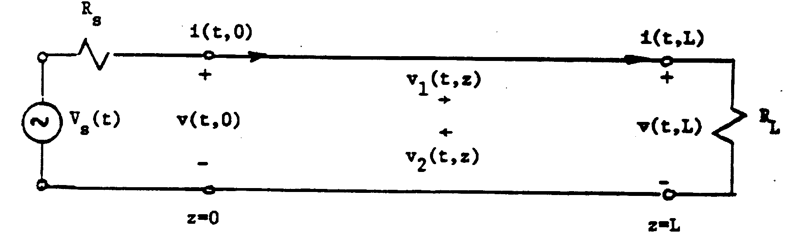
Fig. 7
The boundary conditions at the two ends of the line are
$$V_{s}\left(t\right)=R_{s}i\left(t,0\right)+v\left(t,0\right)$$
$$R_{L}i\left(t,L\right)=v\left(t,L\right)$$
The voltage and current on the transmission line can be decomposed into two waves travelling in ±z direction with velocity u:
$$\begin{aligned}\left[\begin{matrix}v\left(t,z\right) \\ i\left(t,z\right)\end{matrix}\right]=\left[\begin{matrix}v_{1}\left(t,z\right) \\ i_{1}\left(t,z\right)\end{matrix}\right]+\left[\begin{matrix}v_{2}\left(t,z\right) \\ i_{2}\left(t,z\right)\end{matrix}\right] \\ \left[\begin{matrix}v_{1}\left(t−z/u, 0\right) \\ i_{1}\left(t−z/u, 0\right)\end{matrix}\right]+\left[\begin{matrix}v_{2}\left(t−\frac{L−z}{u}L\right) \\ i_{1}\left(t−\frac{L−z}{u}L\right)\end{matrix}\right], \\ v_{1}\left(t,z\right)=Z_{0}i_{1}\left(t,z\right);v_{2}\left(t,z\right)=−Z_{0}i_{2}\left(t,z\right)\text{.}\end{aligned}$$
Here, we stressed the dependence of the +z going wave on the value at the “source” end of the line z=0 and the dependence of the -z going wave on the value at the “load” end of the line at z=L.
The boundary conditions can now be written as
$$\begin{aligned}V_{s}\left(t\right)=\frac{R_{s}}{Z_{0}}\left\{v_{1}\left(t,0\right)−v_{2}\left(t,0\right)\right\}+\left\{v_{1}\left(t,0\right)+v_{2}\left(t,0\right)\right\} \\ \frac{R_{L}}{Z_{0}}\left\{v_{1}\left(t,L\right)−v_{2}\left(t,L\right)\right\}+\left\{v_{1}\left(t,L\right)+v_{2}\left(t,L\right)\right\}\end{aligned}$$
We observe the boundary condition (B.C.) at z=0 is greatly simplified if the source resistance Rs is equal to Z0, i.e. matched to the line. In this case the B.C. becomes
$$V_{s}\left(t\right)=2v_{1}\left(t,0\right) \text{or} v_{1}\left(t,0\right)=\frac{V_{s}\left(t\right)}{2}$$
In fact, the +z going wave neither depends on the length of the line nor on the terminating resistor RL. It is the same as that excited by the source on an infinitely long line. The B.C. as z=L yields
$$\frac{v_{2}\left(t,L\right)}{v_{2}\left(t,L\right)}=\frac{\left(R_{L}/Z_{0}\right)−1}{\left(R_{L}/Z_{0}\right)+1}=Γ_{L}$$
i.e. the waveform of the -z going wave a z=L is the same as that of the +z going wave there. Physically, v1(t,L) incident at the load causes a reflection and we speak of v2(t,z) as the reflected wave with ΓL the reflection coefficient. ΓL varies between -1 (RL=0), 0 (RL=Z0) and +1 (RL=∞) as shown in Fig. 8.
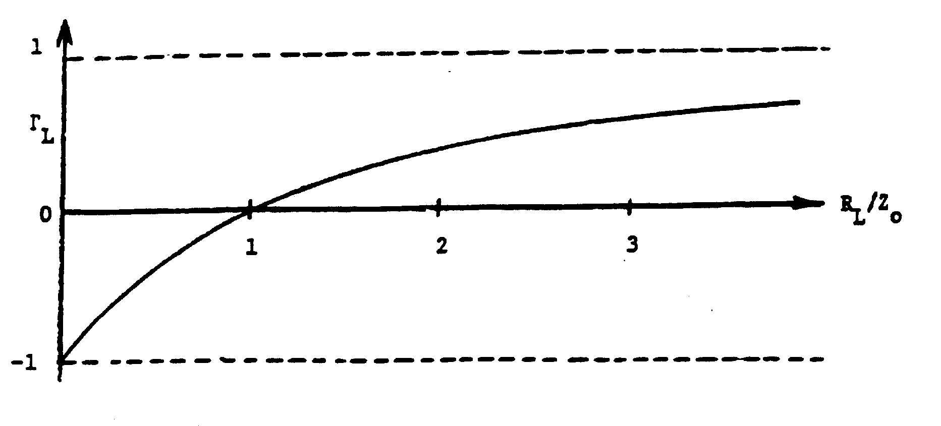
Fig. 8
When $v_{2}\left(t,z\right)$ reaches the source end it is not reflected because Rs=Z0. Fig. 9a shows a plot of a temporal waveform at various locations while Fig. 9b shows spatial waveforms at various times.
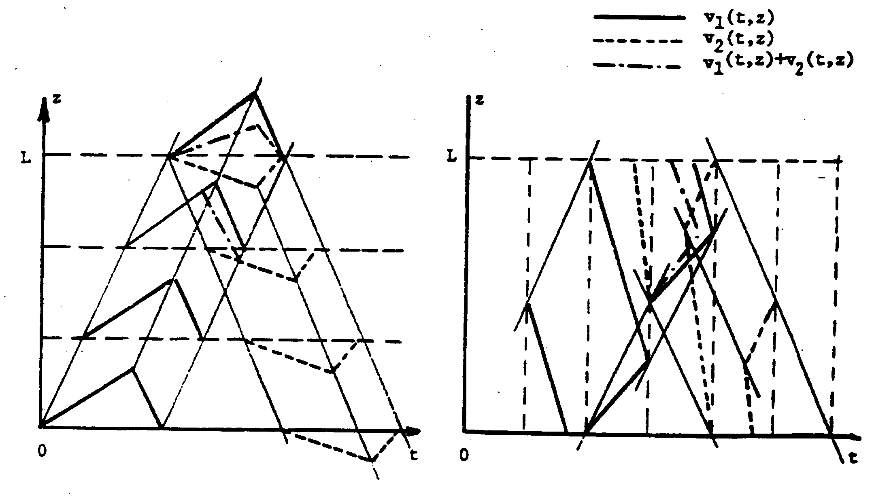
9a Fig. 9 9b
7. Multiple Reflection:
If the source resistance Rs is not equal to Z0, $v_{2}\left(t,z\right)$ will be reflected, thus producing another +z going wave $v_{3}\left(t,z\right)$ given by
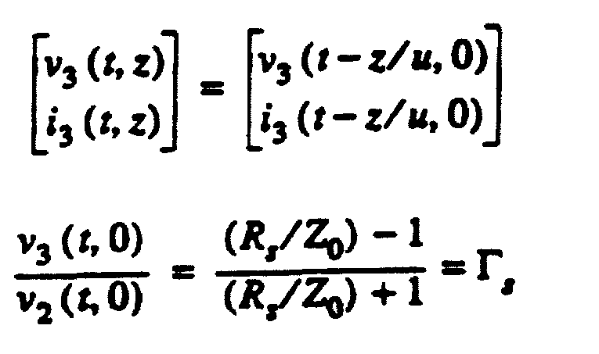
When this wave hits the load end it is again reflected, yielding a -z going wave
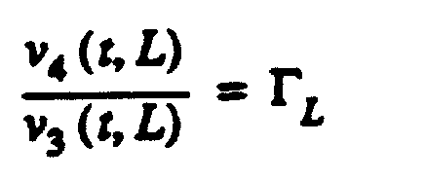
Thus, as shown in Fig. 10 there is multiple reflection. Unless $\left|Γ_{s}\right|=\left|Γ_{L}\right|=1$ ,the amplitude of the reflected wave will gradually approach zero. The total voltage and current on the line are
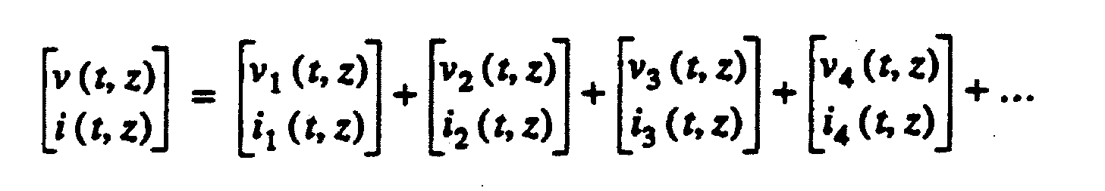
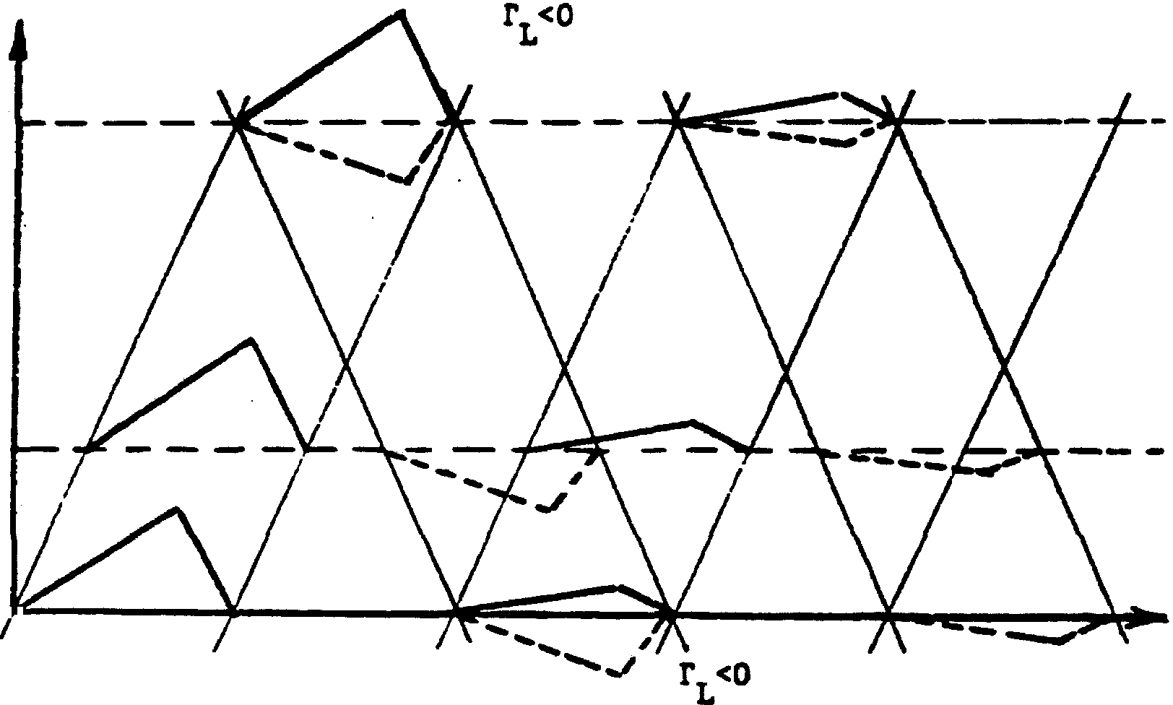
Fig. 10
8. Effect of a Discontinuity:
When two transmission lines of different characteristic impedances are connected in cascade, the discontinuity generates a reflected wave. Fig. 11 shows such a configuration. Without loss of generality we assume the two ends are matched to the respective characteristic impedances. We expect a wave $v_{1}\left(t,z\right)$ incident on the discontinuity at z=L to generate a reflected
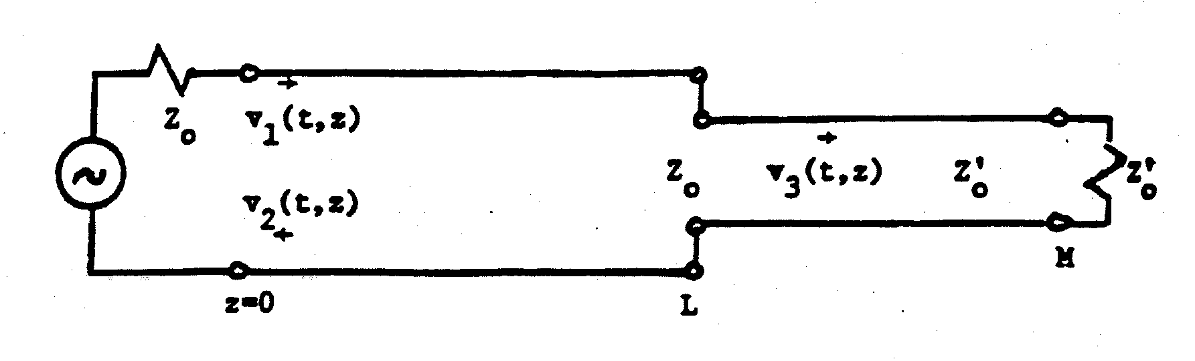
Fig. 11
wave $v_{2}\left(t,z\right)$ to the left and a transmitted wave $v_{3}\left(t,z\right)$ to the right. The boundary conditions at the discontinuity are
$$\begin{aligned}v_{1}\left(t,L\right)+v_{2}\left(t,L\right)=v_{3}\left(t,L\right) \\ i_{1}\left(t,L\right)+i_{2}\left(t,L\right)=i_{3}\left(t,L\right)\end{aligned}$$
or
$$\frac{1}{Z_{0}}\left\{v_{1}\left(t,L\right)−v_{2}\left(t,L\right)\right\}=\frac{1}{Z_{0}}v_{3}\left(t,L\right)$$
Solving for $v_{2}\left(t,L\right), v_{3}\left(t,L\right)$ we find
$$\frac{v_{2}\left(t,L\right)}{v_{1}\left(t,L\right)}=\frac{\left(Z_{0}/Z_{0}\right)−1}{\left(Z_{0}/Z_{0}\right)+1}, \frac{v_{3}\left(t,L\right)}{v_{1}\left(t,L\right)}=\frac{2\left(Z_{0}/Z_{0}\right)}{\left(Z_{0}/Z_{0}\right)+1}$$
As far as the line to the left of the discontinuity is concerned, it sees a resistance Z0, the characteristic impedance of the line to the right. Both the reflected and the transmitted waves at the discontinuity have the same temporal waveform as the incident wave.
9. Input Impedance:
Let us return to the finite transmission line of Fig. 7. When the voltage source is a sine wave of angular frequency ω, the voltage and current everywhere on the line are sine waves of the same frequency. Thus
$$\frac{v\left(t,z\right)}{v\left(t,z\right)}=\text{Re}\left\{\left[\frac{1}{1/Z_{0}}\right]V_{1}e^{jω\left(t−z/u\right)}+\left[\frac{1}{−1/Z_{0}}\right]V_{2}e^{jω\left(t−\frac{L}{u}−\frac{L−z}{u}\right)}\right\}$$
where V1 and V₂ are the complex amplitudes of the two waves. If the reflection coefficient at Z=L is ΓL then
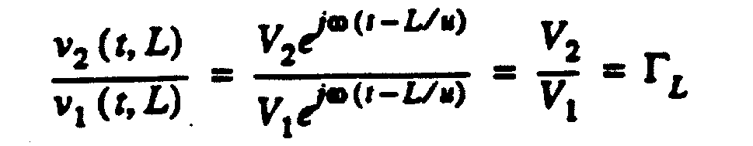
So far we have only considered resistive termination RL where ΓL is real. The voltage and current at z = 0 are therefore
We can define an input impedance of the line looking to the right at z = 0 as the ratio of the complex voltage and complex current
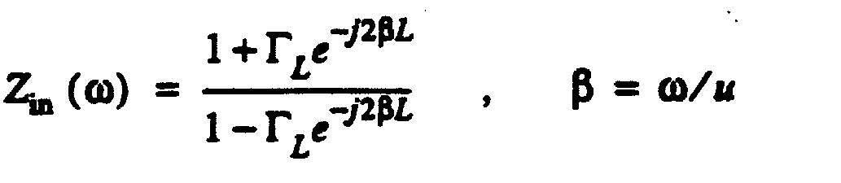
We observe the input impedance of a transmission line is a function of the reflection coefficient at the end of the line and the total phase shift or electrical length of the line βL = ωL/u.
As an example, consider RL = 0 , i.e. ΓL = -1. The input voltage and current become
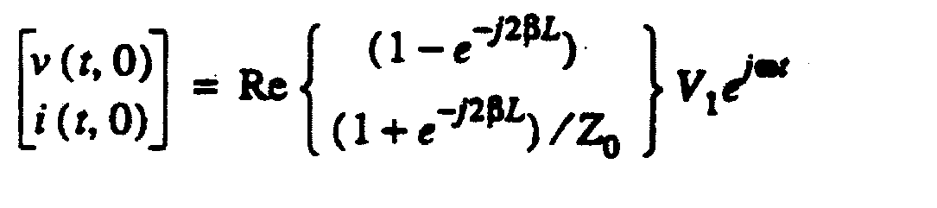
and the input impedance
.
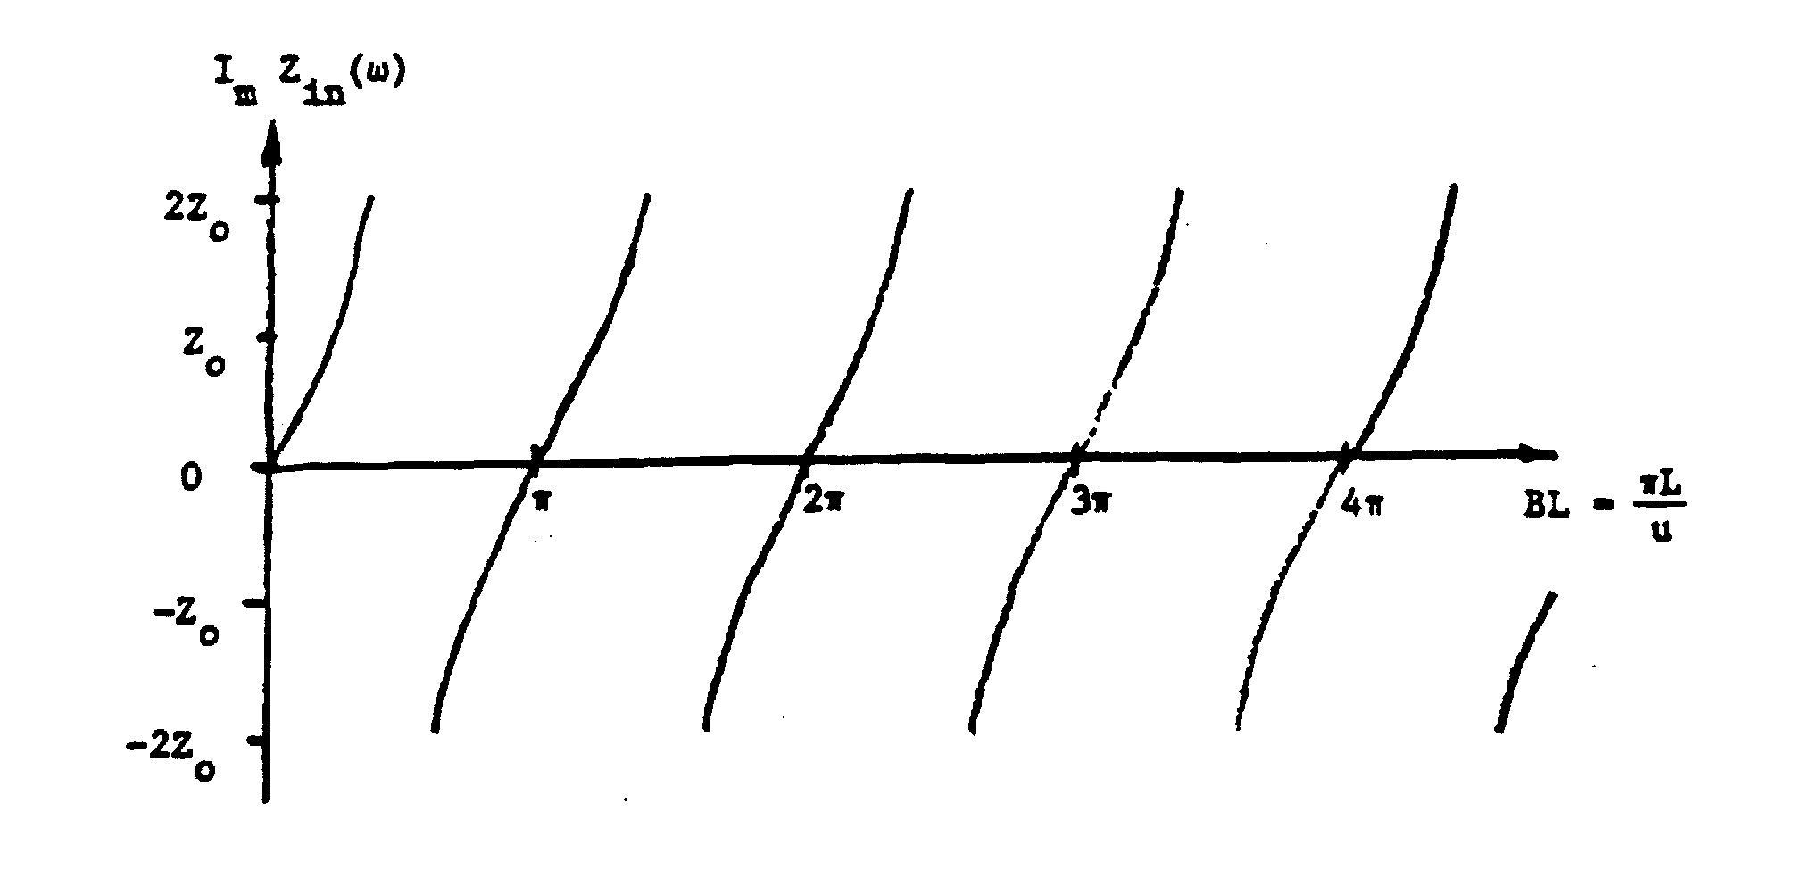
Fig. 12
The input voltage becomes zero when 2βL=2nπ. Since β=2π/λ, this relation is L=nλ/2 or multiples of half a wavelength. At these frequencies the current will be a maximum and the input impedance is zero. On the other hand, at frequencies where 2βL=(2n+1)π the voltage at z=0 is a maximum while the current vanishes. Thus the input impedance becomes infinite. We have an infinite number of impedance zeros interleaved with an infinite number of impedance poles (Fig. 12). The short-circuited transmission line therefore behaves as a resonator. The impedance is a transcendental function of frequency. In a lumped circuit the impedance is the ratio of two polynomials of frequency. This is the main difference between a lumped circuit and a transmission line or a distributed circuit.
It is evident that under sinusoidal excitation the transmission line need not be terminated in a resistor to have sinusoidal voltage and currents everywhere. Any linear termination containing R, L, C, M, will also be in the same situation. Thus we can consider a complex load impedance ZL which will produce a complex reflection coefficient
$$Γ_{L}=\frac{\left(Z_{L}/Z_{0}\right)−1}{\left(Z_{L}/Z_{0}\right)+1}$$
The input impedance Zin(ω) expression given before remains valid.
It is to be noted that with non-resistive termination, the reflected waveform is in general different from that of the incident waveform. A reflection coefficient is only meaningful for sinusoidal excitation.
10. Experimental Procedure:
We study the fundamental behaviour of travelling waves on a transmission line using the configuration of Fig. 5 and Fig. 13. The coaxial line has several test points where the voltage can be monitored.
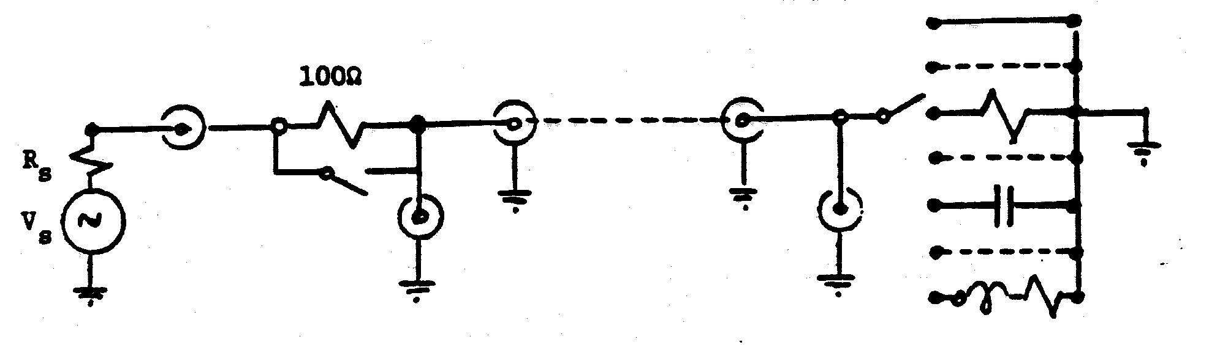
Fig. 13
A. Determination of the characteristic impedance Z0:
Use a pulse generator and set up a suitable pulse train without the transmission line connected. Connect the transmission line and observe the input waveform. When the terminating resistance is equal to the characteristic impedance of the line there will be no reflection at the far end. The waveform at the input of the line will be the same as the generator waveform except for a change in amplitude. Vary the terminating resistance and find the value for no reflection. This is the characteristic impedance of the line and will be used for the remainder of the experiment. With this termination only one travelling wave will be excited.
B. Determination of V₁ (t, 0)/i₁ (t, 0):
For a wave in +z direction v₁ (t, z) /i₁ (t, z) = Z₀. v₁ (t, 0) can be observed directly in the experimental set-up. To determine i₁ (t, 0) observe the generator voltage Vg(t) and the value of the series resistor R. The resulting Z₀ should be the same as that of part A.
C. Observation of travelling waves:
With a pulse train drive observe the voltage waveforms at various test points on the line. Be sure to synchronize the oscilloscope to the wave form at the input end of the line so that time delay down the line can be observed. Plot the voltage waveform as functions of time for the different position using the same time base. Plot the waveform as functions of positions for selected values of time using the same position origin.
D. Determination of velocity of propagation:
From the data of part C and the physical length of the line, determine the velocity of propagation. Compare this velocity with the velocity of light in free space and determine the dielectric constant of the insulating medium used in the line.
E. Phase velocity and wavelength:
With a sinusoidal drive observe and plot the space-time behaviour of voltage as in part C. By varying the frequency, determine the frequencies at which the phase shift between the two ends are multiples of 2π. Determine the length of the line in wavelengths at these frequencies.
F. Simple Reflection
Use a pulse generator whose source impedance is 50 Ohm to excite the line so that no multiple reflection occurs. Use a pulse width approximately equal to the total delay of the transmission line. Observe the voltage waveforms at the end points with RL = 0, 20, 100, ∞. Compare the reflection coefficient with expected value for each case. Observe and plot waveforms at other test points for RL = 20 as functions of time and as functions of position for selected values of time.
G Multiple Reflection:
Use a 100 Ohm resistor in series with the source and a load resistor of 20 Ohm. Using the same pulse width, observe and plot the voltage at all test points. Compare the waveform at the load with expected amplitudes of each of the waves. Repeat with a pulse width approximately 10 times the delay time of the line.
H Input Impedance:
Terminate the 50 Ohm line in a short circuit. Drive the line with a sine wave generator through the series 100 Ohm resistor. Vary the frequency and observe the voltage waveform at the input of the line V1 , and at the generator terminal Vg on the same time base. Find frequencies at which the V1 is a minimum. Determine the length of the line in terms of wavelengths at these frequencies. Observe the amplitude of Vg at these frequencies. Evaluate the input current of the line at one of these frequencies and show that it is a maximum.
Terminate the line in a .01 μf capacitor. Observe V₁ versus frequency and note the frequencies for minimum values. Compare with those of the short circuit case and explain.

