Rev. 20 Jan.,2004 UNIVERSITY OF TORONTO

Department of Electrical and Computer Engineering

FIELDS AND WAVES LABORATORY

Courses ECE 320F and ECE 357S

III Year

DESIGN OF A DOUBLE STUB MATCHING NETWORK

1. Object
The input impedance and the reflection coefficient of a transmission line are investigated. The transformation between the two is introduced with graphical aids. The measurement and interpretation of voltage standing wave ratio is discussed.
2. References:
- Your lecture notes.
- D.K. Cheng, "Field and Wave Electromagnetics", Chap. 9..
- U.S. Inan and A.S. Inan, "Engineering Electromagnetics", Chap. 2.
3. State of a Transmission Line and its Representations:
Two representations have been introduced to describe the physical "state" of a transmission line under specific excitation:

Voltage-current representation: $\begin{aligned}\left[v(t,z) | \right] \\ \end{aligned}$

Travelling wave representation: $\begin{aligned}\left[v_{1}(t,z) | \right] \\ \end{aligned}$

where $\begin{aligned}\left[v_{1}(t,z) | \right] \\ \end{aligned}$

The relation between the two representations is
$$\begin{aligned}\left[v_{1}(t,z) | \right] \\ \end{aligned}$$

and its inverse

$$\left[\begin{matrix}v_{1}(t,z) \\ v_{2}(t,z)\end{matrix}\right]={\left[\begin{matrix}1 & 1 \\ 1/Z_{0} & −1/Z_{0}\end{matrix}\right]}^{−1}\left[\begin{matrix}v(t,z) \\ i(t,z)\end{matrix}\right]=\frac{1}{2}\left[\begin{matrix}1 & Z_{0} \\ 1 & Z_{0}\end{matrix}\right]\left[\begin{matrix}v(t,z) \\ i(t,z)\end{matrix}\right]$$

The "state" of the transmission line can be expressed in terms of either representation. Knowing one, the other is uniquely derived.
Under sinusoidal excitation, phasors can be introduced to describe all variables. If we use time dependence exp there follows:

$$\left[\begin{matrix}v(t,z) \\ i(t,z)\end{matrix}\right]=\text{Re}\left[\begin{matrix}V(\text{t,z}) \\ I(\text{t,z})\end{matrix}\right],\left[\begin{matrix}V(t,z) \\ I(t,z)\end{matrix}\right]=e^{jωt}\left[\begin{matrix}V(z) \\ I(z)\end{matrix}\right]$$

$$\left[\begin{matrix}v_{1}(t,z) \\ v_{2}(t,z)\end{matrix}\right]=\text{Re}\left[\begin{matrix}V_{1}(t,z) \\ V_{2}(t,z)\end{matrix}\right],\left[\begin{matrix}V_{1}(t,z) \\ V_{2}(t,z)\end{matrix}\right]=e^{jωt}\left[\begin{matrix}V_{1}(z) \\ V_{2}(z)\end{matrix}\right]$$

The transformation between $\left[\begin{matrix}V(z) \\ I(z)\end{matrix}\right]$ and$\left[\begin{matrix}V_{1}(z) \\ V_{2}(z)\end{matrix}\right]$ is still given by the same pair of square matrices as before. 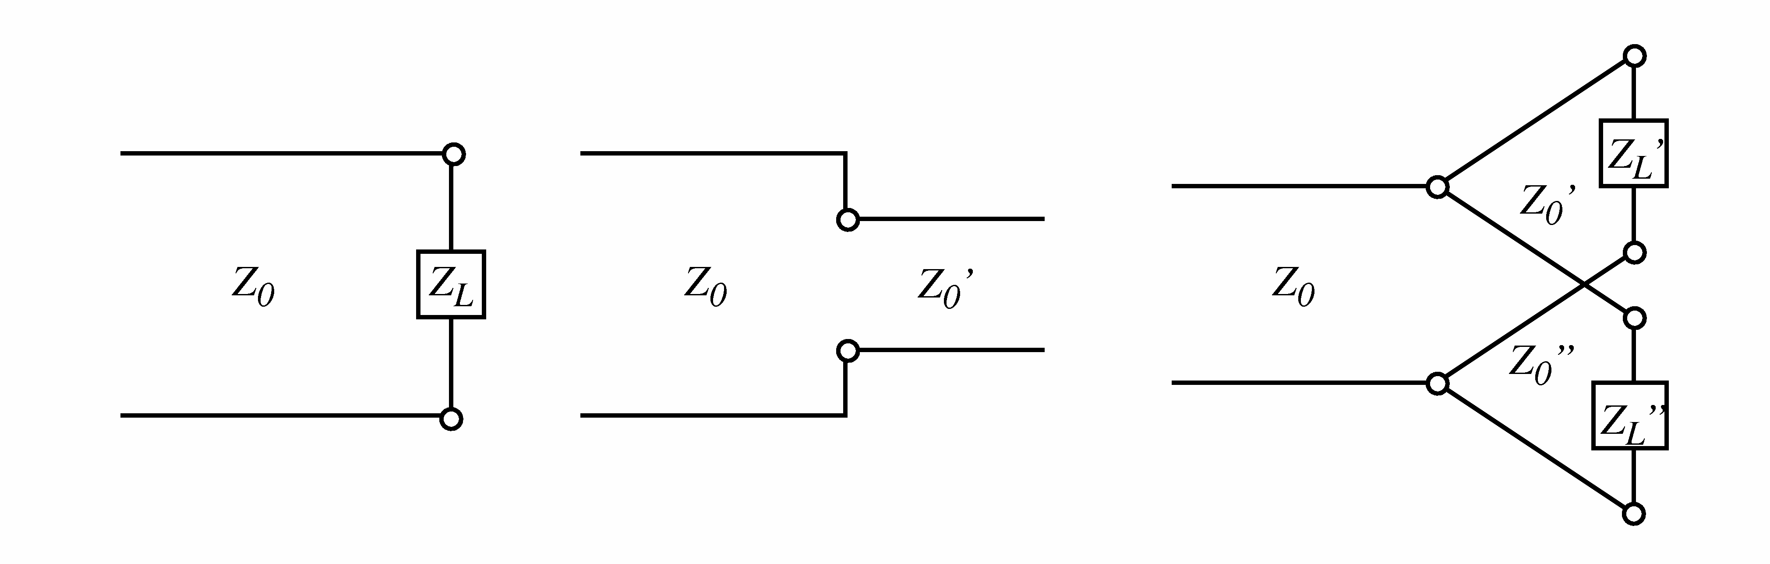
Fig. 1

Which representation to use depends upon the problem to be solved. The travelling wave representation is most suitable to describe the effect of a length of transmission line because $β=ω/u$.
$$\left[\begin{matrix}V_{1}(z) \\ V_{2}(z)\end{matrix}\right]=\left[\begin{matrix}e^{−jβz}V_{1}(0) \\ e^{−jβz}V_{1}(0)\end{matrix}\right]=\left[\begin{matrix}e^{−jβz} & 0 \\ 0 & e^{jβz}\end{matrix}\right]\left[\begin{matrix}V_{1}(z) \\ V_{2}(z)\end{matrix}\right]$$

The waves at two ends of the line are only different by a phase shift of , i.e. the electrical length of the line. On the other hand, if we need to impose voltage and current constraints such as at the junction of a line and an impedance, of two different lines, or of many lines as shown in Fig. 1, it is more convenient to use the voltage-current representation.
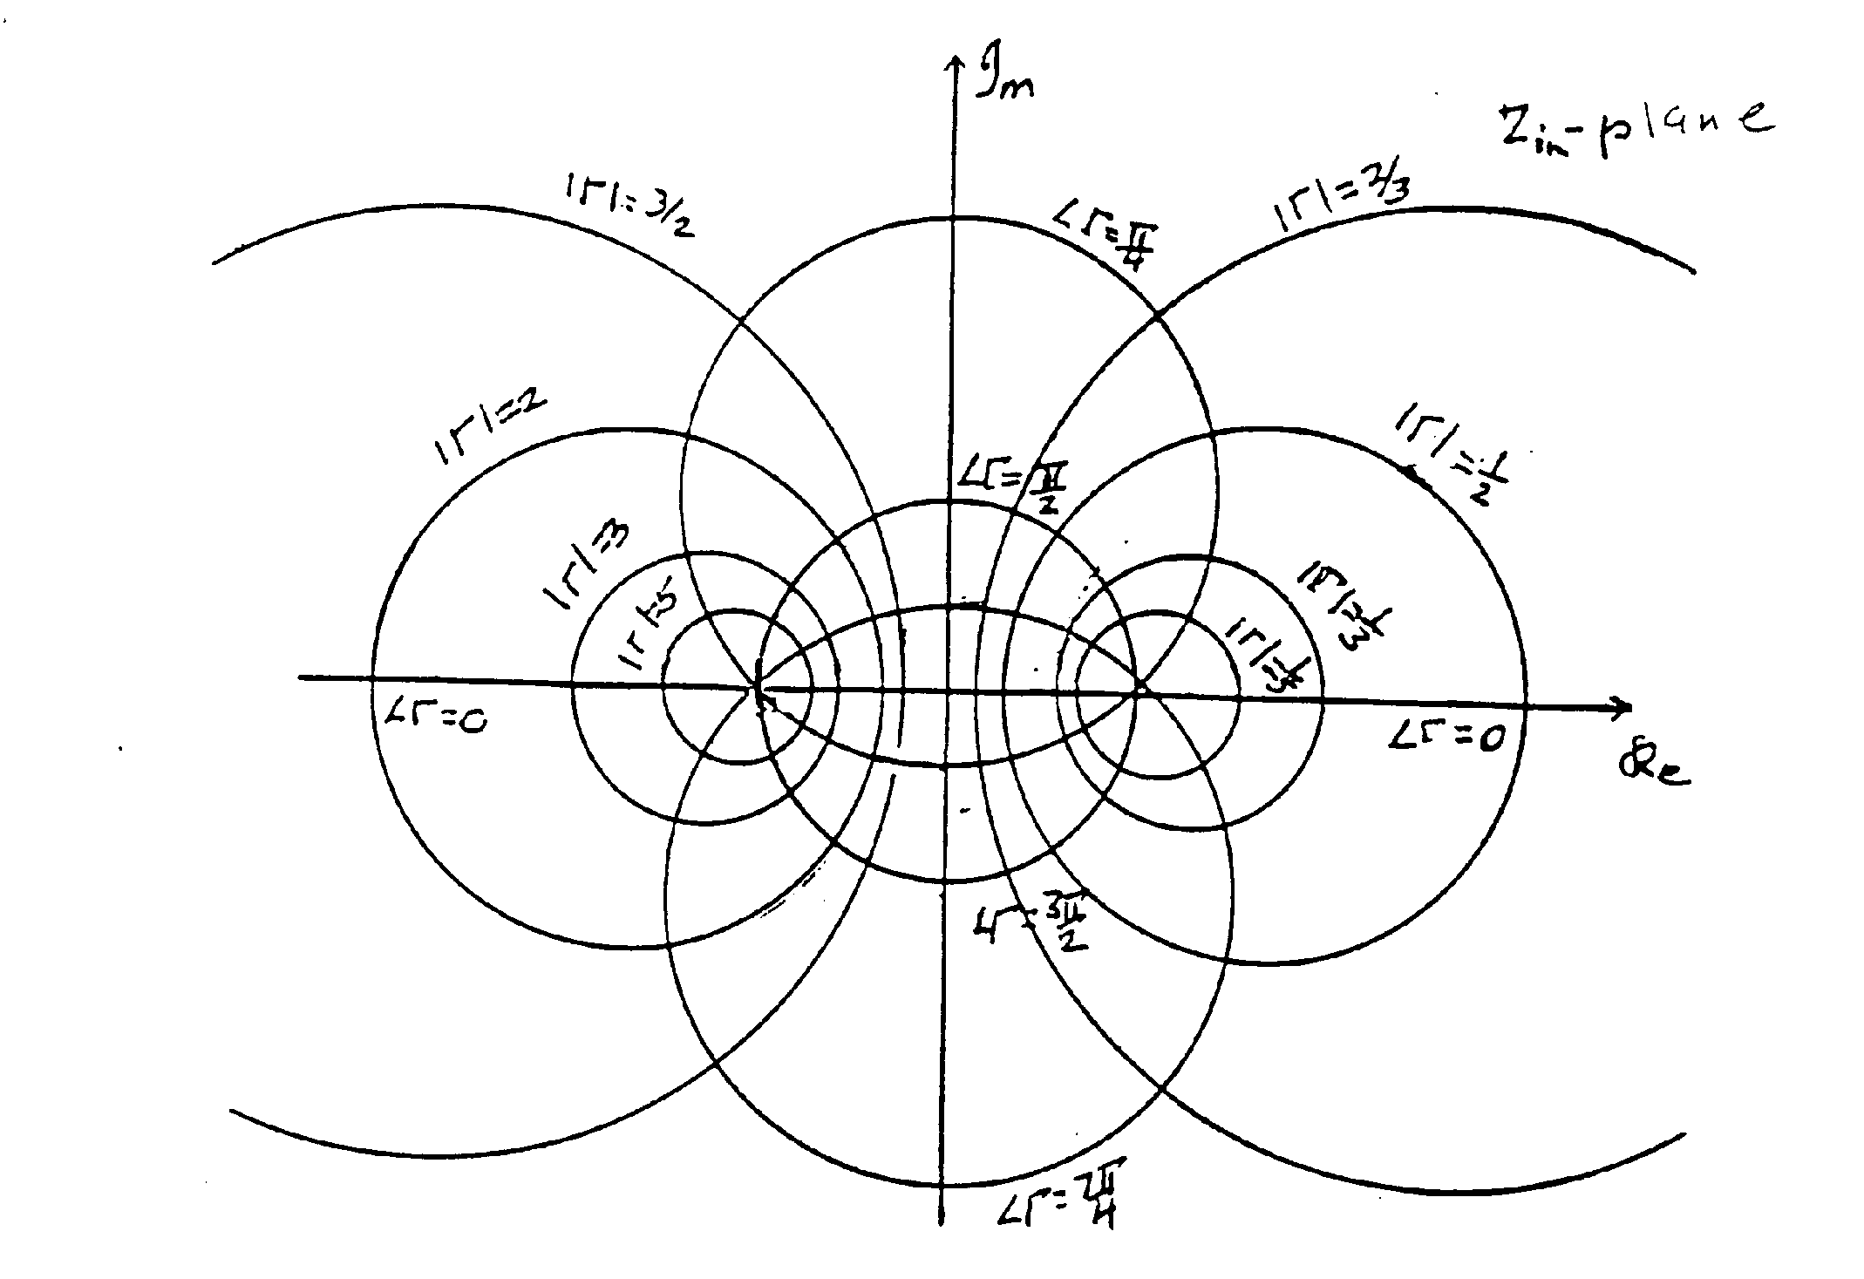
Fig. 2

4. Input Impedance and Reflection Coefficient:
Quite often one is interested in the "state" of the transmission line except for a common multiplicative "amplitude". Thus it is often required to know the input impedance $Z_{\text{in}}(z)$ (admittance $Y_{\text{in}}(z)$ ) looking to the +z direction and the input reflection coefficient $Γ(z)$ looking to the same direction. These are defined as

$\begin{aligned}Z_{\text{in}}(z)=V(z)/I(z) \\ Γ(z)=V_{2}(z)/V_{1}(z)\end{aligned}$ , $Y_{\text{in}}(z)=1/Z_{\text{in}}(z)$
.
Knowing the transformation between the two representations, it is easy to derive the relation between the above two variables:
$$Z_{\text{in}}(z)=\frac{V_{1}(z)+V_{2}(z)}{V_{1}(z)/Z_{0}−V(z)/Z_{0}}=Z_{0}\frac{1+Γ(z)}{1−Γ(z)}$$
$$Γ(z)=\frac{V(z)−Z_{0}I(z)}{V(z)+Z_{0}I(z)}=\frac{Z_{\text{in}}(z)−Z_{0}}{Z_{\text{in}}(z)+Z_{0}}$$

The nature of the transformation between the two complex variables is shown in Figs. 2 and 3. It is a bilinear transformation which maps circles on one plane to circles on the other. The point is mapped to the origin . The imaginary axis Re is mapped onto the circle . The right half plane Re is mapped onto the interior of the above circle. The real axis Im is mapped onto the real axis in the plane. A chart describing the transformation on the plane is commonly used as a graphical aid to experiments and is known as the Smith chart. The amplitude and phase of can also be graphically determined as in Fig. 4.
A further important relation is that as we move along the transmission line, the reflection coefficient is transformed along a circle centred at the origin:
$$Γ(0)=\frac{V_{2}(0)}{V_{1}(0)}=\frac{e^{−jβz}V_{2}(z)}{e^{jβz}V_{1}(z)}=Γ(z)e^{−j2βz}$$
Every half wavelength corresponds to one complete rotation (Fig. 5). Based upon this relation we derive the transformation of input impedance by a transmission line as follows:

$$\frac{Z_{\text{in}}(0)}{Z_{0}}=\frac{1+Γ(0)}{1−Γ(0)}=\frac{1+e^{−j2βz}Γ(z)}{1−e^{−j2βz}Γ(z)}=\frac{Z_{\text{in}}(z)+{\text{jZ}}_{0}\text{tan}βz}{Z_{0}+{\text{jZ}}_{\text{in}}(z)\text{tan}βz}$$
This transformation is quite complicated and hence it is much easier to work in the instead. Note that $Z_{\text{in}}(z)=Z_{0}$ is a fixed point of the transformation. No matter what is the length of the line, if $Z_{\text{in}}(z)=Z_{0}$ at some z , it is the same everywhere.
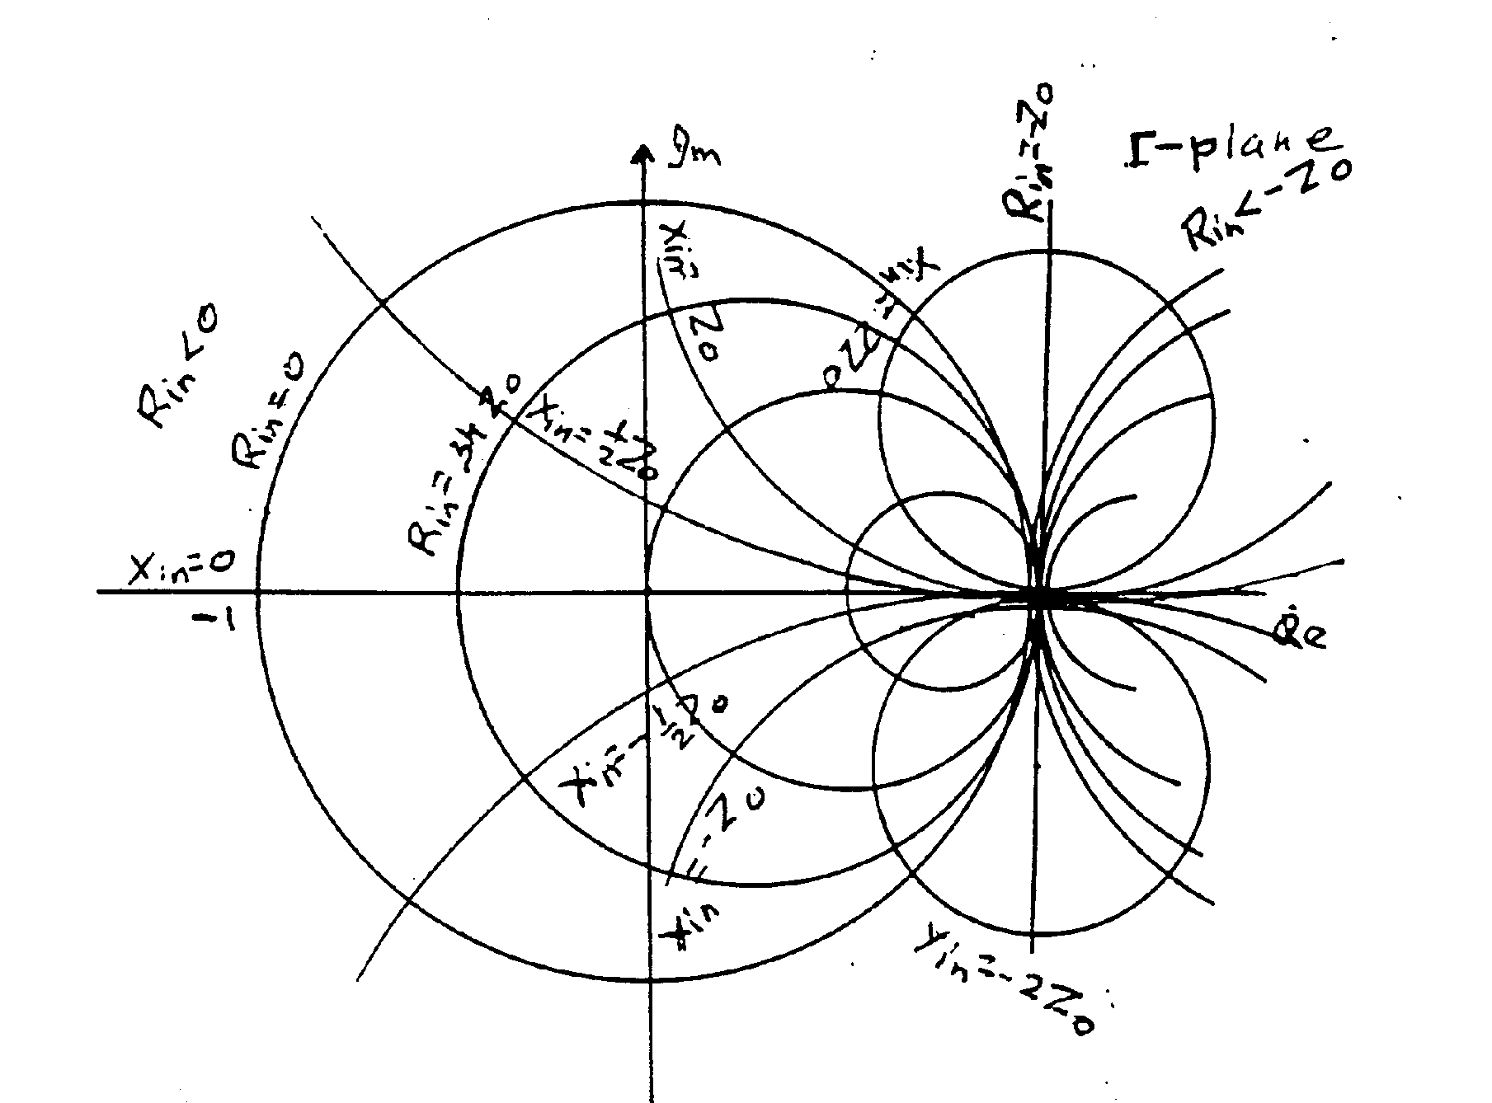
Fig. 3

5. Transmission Line Measurement and Voltage Standing Waves:
Both $Z_{\text{in}}(z)$and $Γ(z)$ at a transmission line port can be measured directly. However, since transmission lines vary in configuration, special instruments are required. This is particularly true at high frequencies because in connecting to an instrument, discontinuities with length say of 1/25 to 1/100 of wavelength may seriously affect the results.
A simple indirect measurement requiring relatively simple instrumentation is to measure the distribution of voltage amplitude along the transmission line. This can be readily done on a coaxial transmission line by cutting a longitudinal slot such that the current flow on the inside wall is not disturbed. A probe is then inserted into the coaxial line through the slot to sample the electric field or the voltage. The probe is mounted on a moving carriage which can sample the voltage distribution at different positions. A detector and an amplifier are used to find the relative amplitude. Such a line is known as a slotted line. The measurement is known as the voltage standing wave measurement.

The amplitude of voltage on a transmission line is given by

$$\left|v(z)\right|=\left|V_{1}(z)+V_{2}(z)\right|=\left|e^{−jβz}V_{1}(0)+e^{+jβz}V_{2}(0)\right|=\left|V_{1}(0)\right|\left|1+Γ(0)e^{+j2βz}\right|$$

As shown in Fig. 6, the phase of the reflected wave $V_{2}(z)$ rotates in the counter clockwise direction as z is increased at the rate of one resolution for every half wavelength. As shown in Fig. 7 the amplitude varies between a maximum value

${\left|V\right|}_{\text{max}}=\left|V_{1}(0)\right|\left\{1+\left|Γ(0)\right|\right\}$ located at $∠Γ(0)+2{βz}_{\text{max}}=2nπ$

and a minimum value

${\left|V\right|}_{\text{min}}=\left|V_{1}(0)\right|\left\{1−\left|Γ(0)\right|\right\}$ located at $∠Γ(0)+2{βz}_{\text{min}}=(2n+1)π$

The ratio

$$\frac{{\left|V\right|}_{\text{max}}}{{\left|V\right|}_{\text{min}}}=\frac{1+\left|Γ\right|}{1−\left|Γ\right|}=\text{VSWR}$$

is known as the voltage standing wave ratio. Note that $\left|Γ(z)\right|$ is a constant along the line. This ratio is readily measured using a slotted line from which we find
$$\left|Γ\right|=\frac{\text{VSWR}−1}{\text{VSWR}+1}$$
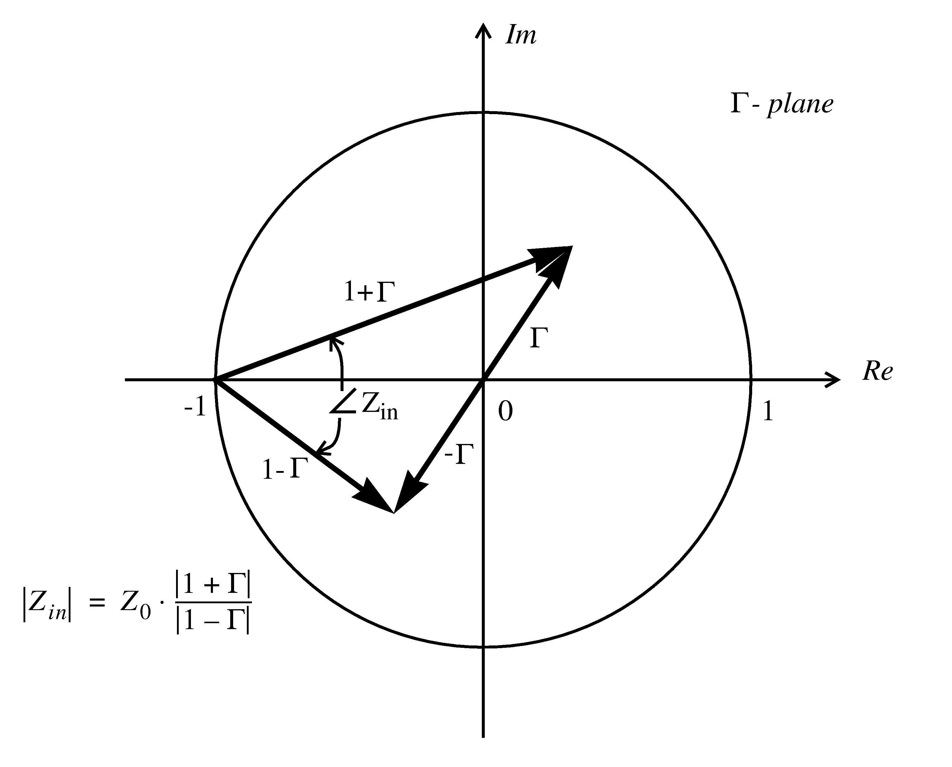
Fig. 4

To determine the phase of $Γ(0)$ at the load as shown in Fig. 7, let the first voltage minimum be located at $z_{\text{min}}=−d_{\text{min}}$. Thus
$∠Γ(0)=π−2{βz}_{\text{min}}=π+2{βd}_{\text{min}}=π+\frac{4{πd}_{\text{min}}}{λ}$
Thus by measuring the VSWR and the position of a voltage minimum, the complex reflection coefficient $Γ(0)$ at the input port of a transmission line can be determined. The input impedance can be derived from the $Γ(z)$to $Z_{\text{in}}(z)$ transformation.
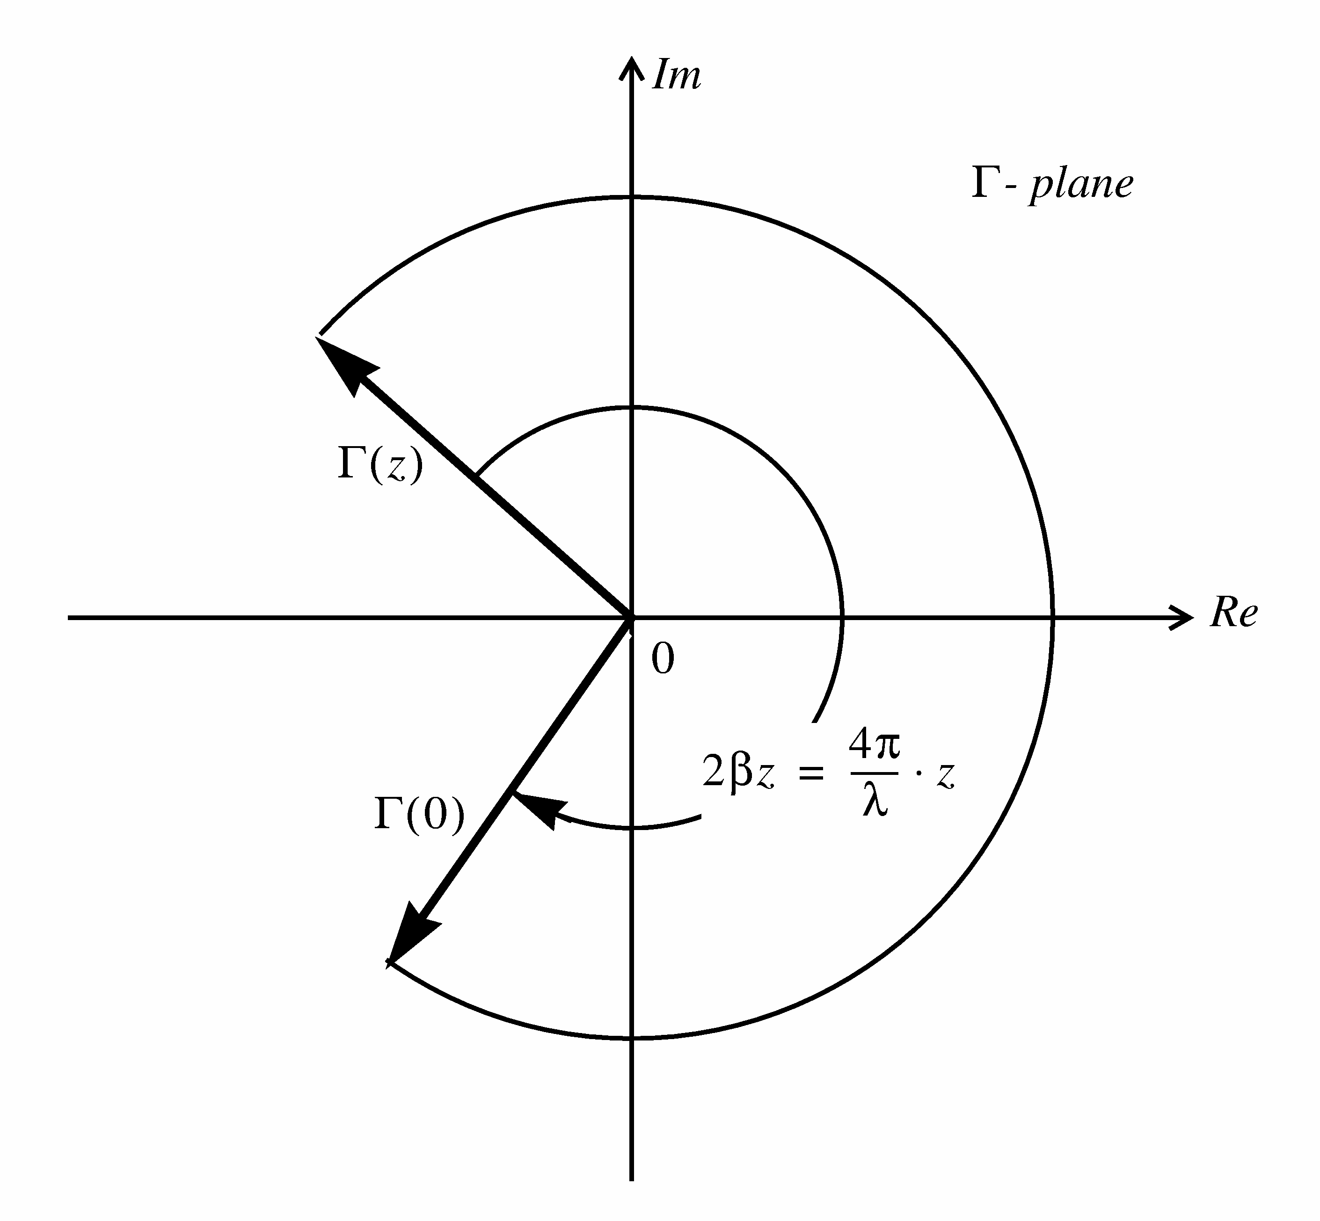
Fig. 5

6. Introduction:
A single stub matching network as shown in Fig. 8 suffers from the disadvantage of being frequency sensitive in that a change of frequency requires a change of separation between the stub and the load, a mechanically cumbersome operation. In a double stub tuner as shown in Fig. 9 the separation between the stubs remains constant and a change of frequency is accommodated by an appropriate adjustment of the stubs resulting in an electrically flexible and mechanically simple system.
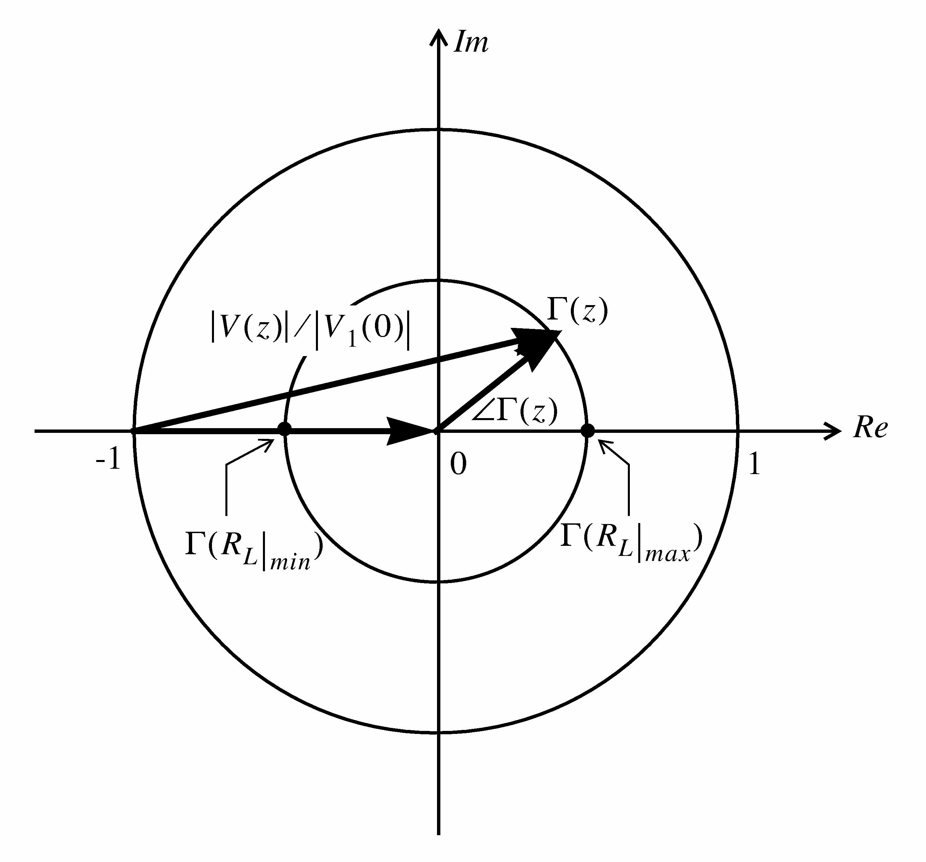
Fig. 6
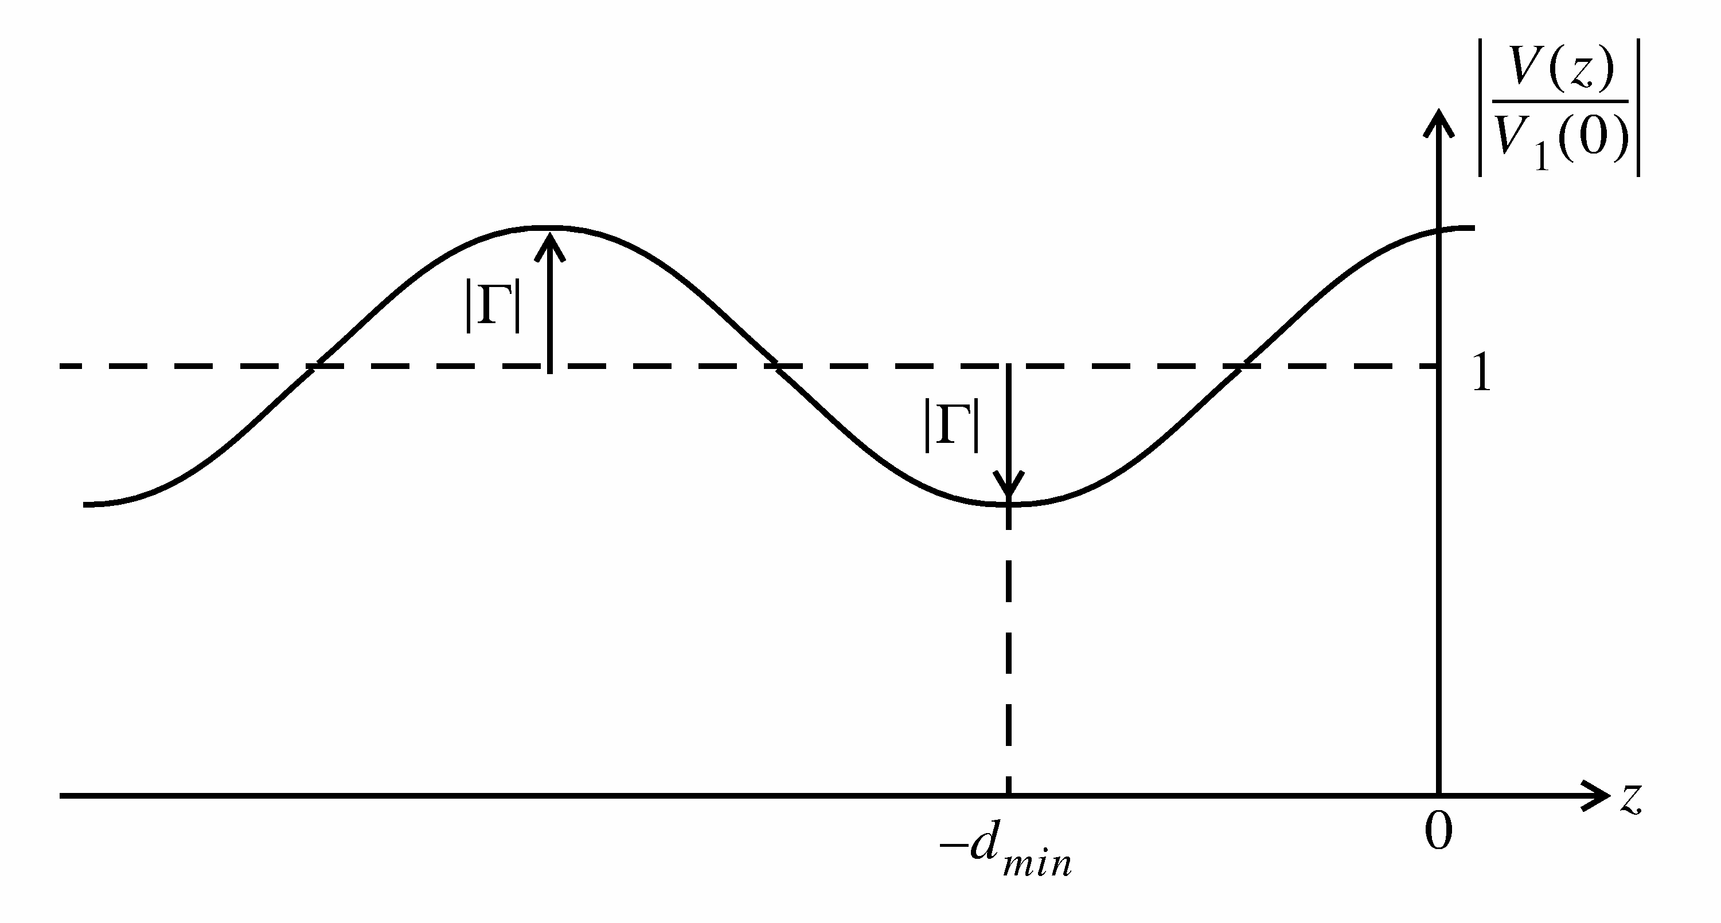
Fig. 7

7. Theory of a Double Stub Matching Network
A cicuit diagram of a double stub matching network is shown in Fig. 9. Stubs d₂ and d₃ separated by distance d₁ transform a specific admittance Y_{A} into Y₀ at the input terminals of the network. The design procedure is illustrated on the Smith chart of Fig. 10 and formulated in the following steps.

- For a perfect match, y_{in} is unity and therefore y_{C} = 1 - jB₂. This means that the y_{C} point is located on the g = 1 circle of the Smith chart.
- The g = 1 circle is rotated counter clockwise (toward the load) on the Smith chart by a distance corresponding the stub separation d₁ (in wavelengths). For y_{C} to lie on the g=1 circle, y_{B} point must lie somewhere on the rotated g = 1 circle as indicated on the Smith chart.
- Since y_{B} = y_{A} + jB₁ (y_{A} and y_{B} have the same conductance), matching is possible for any load y_{A} which lies on a conductance circle intersecting the rotated g=1 circle. Note that for any load within the dark-shaded area in Fig. 10 double-stub matching with this arrangement is not possible. Since there are in general two intersection points of one conductance circle with the rotated g=1 circle, two different designs are possible for a given load y_{A}.
- The susceptance B₁ is given by the required difference in susceptance between y_{A} and the chosen y_{B} on the Smith chart.
- Since the points B and C are separated by a length d₁ of transmission line, y_{B} and y_{C} lie on the same SWR circle. Therefore y_{C} is located by moving clockwise (toward the generator) on the Smith chart a distance d₁ (in wavelengths) from the y_{B} point and by design intersecting with the g = 1 circle.
- Since y_{C} = 1 - jB₂, the susceptance B₂ is given by the required difference in susceptance between y_{C} and the matched position at the centre of the Smith chart.
- Determine the two stub lengths using the Smith chart by starting at the short circuit position and rotating clockwise (toward the generator) along the |Γ| = 1 circle until the required susceptance values are encountered. Then convert the wavelength readings from the Smith chart into physical lengths for each stub.
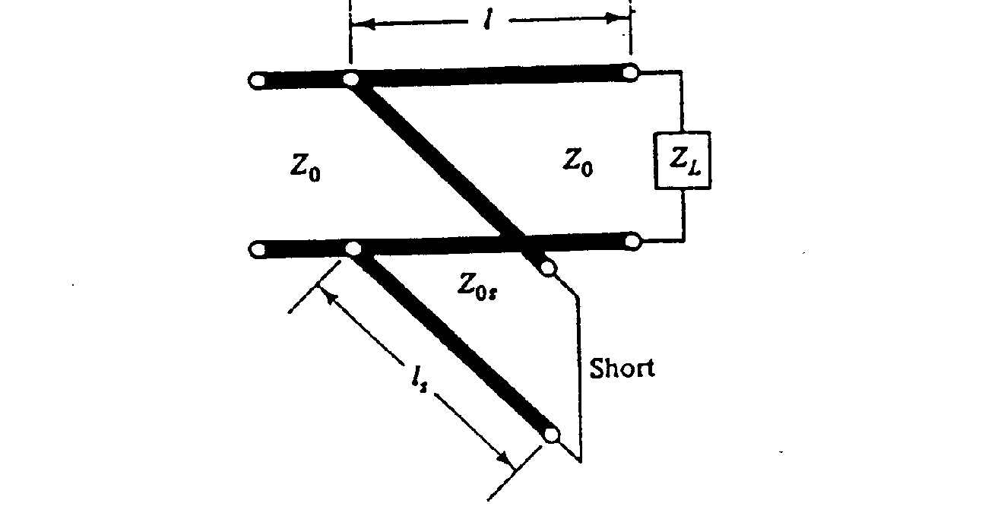
Fig. 8
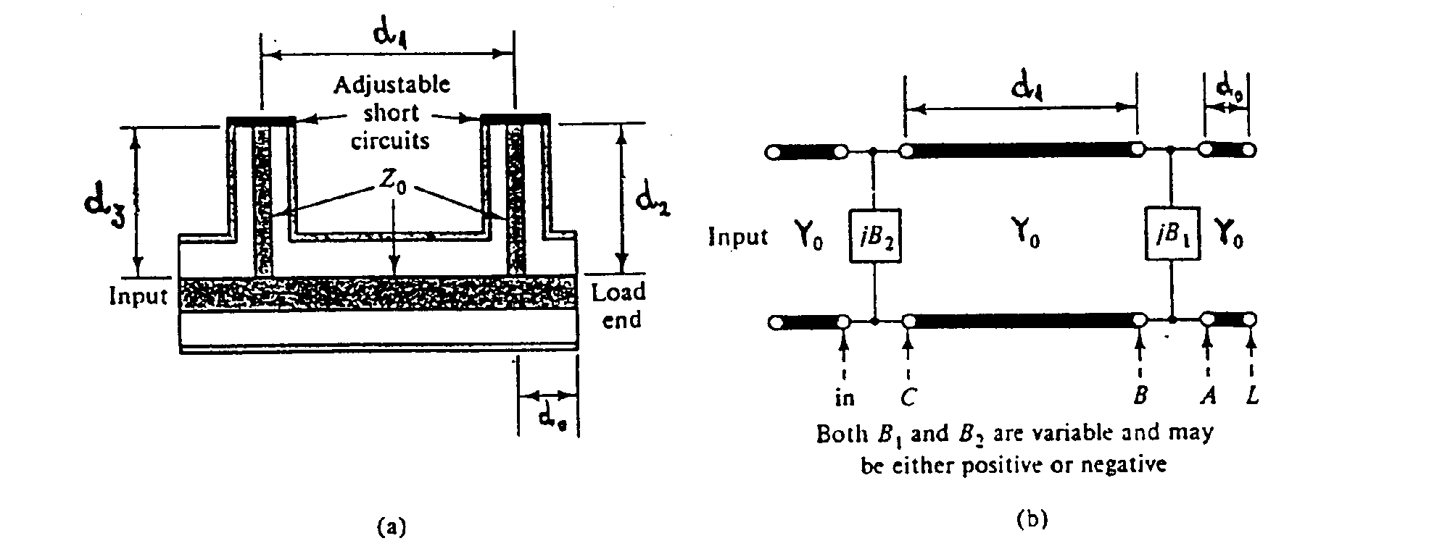
Fig. 9
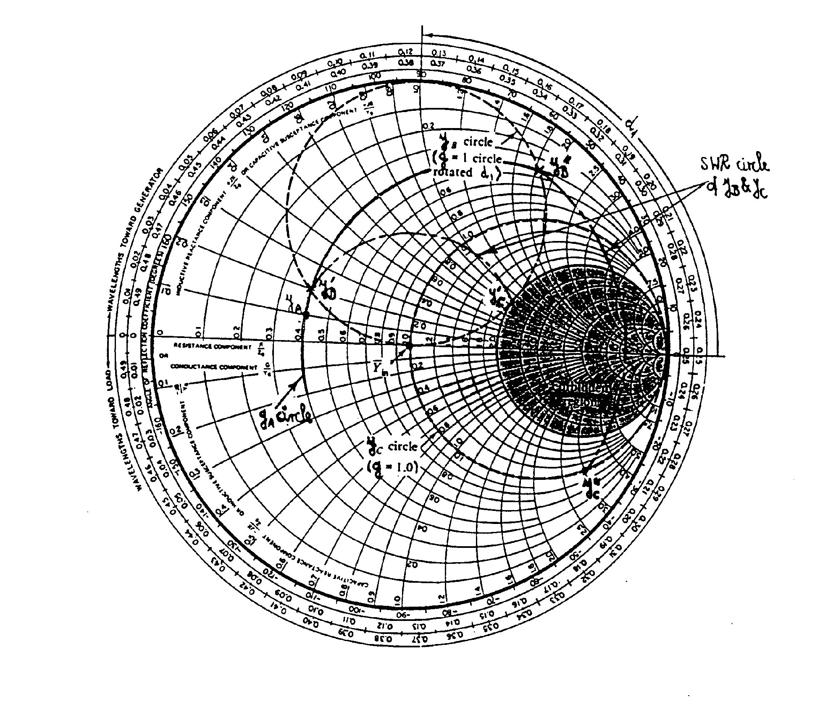
Fig. 10
Experiment
- Calibrate the Vector Network Analyzer (VNA) for reflection measurement by following all the steps explained in part A of the NASWAVE User’s Guide in the appendix.
- Load the NASWAVE program on the diskette provided as explained in part B of the User’s guide.
- Connect the load provided to the SMA cable at the reference and measure its impedance and the VSWR following the steps in part C of the User’s Guide. Record the VSWR, d_{min} and the load impedance and sketch the voltage amplitude distribution along the transmission line.
- Use your measured VSWR and d_{min} to determine the normalized impedance using the Smith Chart. Normalize your measured impedance for verification. Then, using the Smith Chart determine the normalized impedance transferred to the connection point of the first stub (d=3.4 cm). This is the impedance z_{A}.
- Locate the corresponding admittance y_{A}.
- Follow the design procedure outlined in the previous section to design a double-stub matching network. Record both stub lengths in wavelengths as well as in cm. The distance d₁ between the centerlines of the two stubs is 3.8 cm.
- Adjust both stub lengths and measure the VSWR again. Follow procedure D in the User’s Guide for fine tuning. Record your final stub length and VSWR.
NASWAVE⁽¹⁾

Version 2.0

A PROGRAM FOR DISPLAY OF
STANDING WAVES ON THE HP8712ET VECTOR NETWORK ANALYZER(VNA)

USER’S GUIDE

The HP 8712ET Vector Network Analyzer (VNA) has the capability to fundamentally measure the incident, reflected, and transmitted waves that travel along a transmission line. VNA’s have the capability to sweep over a wide frequency range. The 8712ET covers the frequency range 300 KHz to 1.3 GHz. It has the capability to load programs by means of a built-in floppy disk drive.
The software, NASWAVE, is a program written in IBASIC (Instrument BASIC) for displaying standing waves on the VNA display. The standing wave ratio, VSWR, and impedance (Z=R+JX) of a device under test (DUT), or load, can be computed at a single frequency internally in the VNA using the measured reflection coefficient and data obtained from marker positions.

A: CALIBRATING THE SYSTEM

To start any network analyzer measurement, the system has to be calibrated to enhance accuracy at the very beginning of an experiment.

Before inserting the diskette:

To calibrate the 8712ET VNA, the following procedures should be followed:

Definition. REFER TO THE ATTACHED VNA FRONT PANEL DIAGRAM, FIGURE 1. Hardkey refers to the VNA buttons to the right of the display. Softkey refers to the buttons immediately to the right of the display screen with their function displayed on the screen. The numbers in brackets following the softkey definition refer to the position of the softkey button to be pushed.

- Attach the provided cable to the reflection port of the VNA. The cable has a male ‘type N’ connector on one end and a male ‘SMA’connector’ on the other.

- Press PRESET. This sets the VNA to a pre-determined setup including maximum frequency sweep and a set number of points (201) at which measurements are made over the frequency sweep.

- Press MEAS 1 and then the softkey MEAS OFF (7) to turn off Channel 1.

- Press MEAS 2 to turn on Channel 2 for calibration (measurements using the NASWAVE software are made on Channel 2 only and the program customizes Channel 1 to display the standing wave pattern).

- Press the softkey REFLECTION (2).

- Press the hardkey CAL .

- Press the softkeys in this order, MORE CAL (8), CAL KIT (6), 3.5mm (3), PRIOR MENU (8), PRIOR MENU (8 again). Then the softkey ONE PORT (2, NOT DEFAULT 1-PORT) to begin the calibration. Use the SMA open, short, and load that are provided for the calibration. Follow the prompts on the screen for the order in which to attach the calibration components to the male SMA connector.

- Press the hardkey FORMAT then softkey LOG MAG (1).

- Press hardkey MEAS 2 and softkey MEAS OFF (7) to turn off channel 2.

- Press hardkey MEAS 1 to turn on channel 1.

- The VNA is now initialized for loading the program.

B: LOADING THE NASWAVE PROGRAM

- The NASWAVE program is on a 3.5”floppy disk provided. Place the disk in the VNA floppy drive and press the hardkey SAVE/RECALL.

- After the disk directory is displayed press the softkey PROGRAMS (5) and highlight the file NASWAVE using the up and down cursors if necessary.

- Press the softkey RECALL PROGRAM (4) and the program is read into memory. The program is now loaded into memory but not executed.

- To execute the program press the hardkey SYSTEM OPTIONS.

- Press the softkey IBASIC (1) then the softkey RUN (1).

- The program is now installed and VSWR and impedance measurements can be made.

C: MAKING A SWR AND IMPEDANCE MEASUREMENT

- Place the unknown load (DUT) on the male SMA connector at the reference plane where the calibration was preformed.

- To make the VSWR measurement using the installed software press the BEGIN key then the softkey START (1).

- The software prompts the user to enter the test frequency in MHz. Enter 800 MHz and press the hardkey ENTER. The reflection data at each of the 201 points is used to compute the standing wave pattern on a lossless virtual transmission line. After computation the VNA displays the VSWR on the CRT. The X-axis of the display has been setup to show a distance of one wavelength. The 0 point at the right of the screen is the position of the DUT.

- To measure the VSWR and impedance the positions of the voltage maximum and minimum and the distance from the nearest minimum to the DUT are determined with markers. Press the softkey MARKERS (2)--(not the hardkey MARKERS).

- Select the softkey for marker 1 (1), then press the softkey Marker Search (8), softkey Max Search (1)( marker 1 will automatically position itself at the first maximum starting from the left of the CRT). This position is Vmax. Press the softkey Prior Menu (8) twice, this will return you to the marker menu .Select the softkey for marker 2 and press the softkey Marker Search (8), softkey Min Search (2)( marker 2 will automatically position itself at the first minimum starting from the left of the CRT). This position is Vmin. Press the softkey Prior Menu (8) twice, to return to the marker menu. Select the softkey for marker 3 (3) and press the softkey Marker Search (8), softkey Min Search (2). Press the softkey Next Min the Right (3) until marker 3 is located at the minimum closest to position 0 on the X-axis. This position is Dmin.The position and standing wave magnitude of each marker is displayed on the upper right of the VNA CRT (position from the end of the line (on left) is on top and magnitude on the bottom of the display). Press the softkey Prior Menu (8) twice, to return to the marker menu.

- Press the hardkey BEGIN and the user will be returned to the previous software menu.

- To enter the position of the markers into the program press in order the three softkeys, mkr1=Vmax (3), mkr2=Vmin (4), mkr3=Dmin (5). The marker data is now available to the program for computation.

- To compute the VSWR press the softkey VSWR (6)and for the impedance press the softkey IMPEDANCE (7). The values will appear in the display near the bottom of the CRT.

- To make measurements at other frequencies press the softkey START (1) and repeat the measurement procedure.

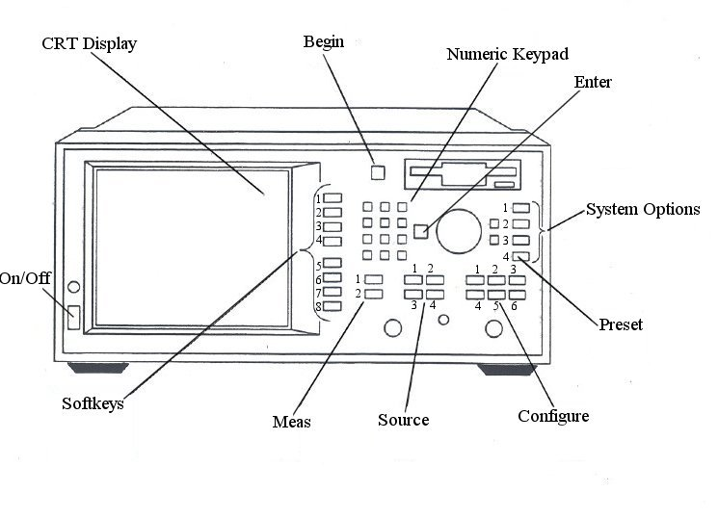

Meas
- Meas 1
- Meas 2

Source
- Freq.
- Sweep
- Power
- Menu

Configure
- Scale
- Display
- Cal
- Marker
- Format
- Ave

System
- Save/Recall
- Hard Copy
- System Options
- Preset

Figure 1. VNA Front Panel

__________________________________________________________________

  - NASWAVE was written by M.S.Z. Khan, C.E. Smith and D. Kajfez of the Electrical Engineering Department, University of Mississippi, University, MS 38677

D: Procedure for Matching the Unknown Load with a Double Stub Tuner

- Remove the unknown load from the SMA cable connector. Attach the double stub tuner female SMA to the cable end and attach the unknown load to the male connector on the double stub tuner.

- Press the hardkey Menu, then the softkey Trigger (1), and then the softkey Continuous (1). The VNA had been setup for a single sweep with the NASWAVE software.

- Press the hardkey MEAS 1, then the softkey MEAS OFF (7).

- Press the hardkey MEAS 2, then the softkey Reflection (2).

- Press the hardkey Format then the softkey Smith Chart (6).

- Adjust the tuning stubs on the double stub tuner until the point defined by the marker is at the 50 ohm impedance the Smith Chart. There is a readout on the upper right of the Smith Chart indicating the impedance.

- With the double stub tuner adjusted to match the unknown load re-do the VSWR measurement by pressing the hardkey Meas 2, then the softkey Meas OFF (7), then press the hardkey Meas 1 to turn on channel 1.

- Press the hardkey Begin then the softkey Start (1) and proceed as before using the same frequency when prompted. The display will come up as a split display at this point. To change to a single display press the hardkey Display, the softkey More Display (8), then the softkey Split Disp (1). Then the Begin and Start keys again.

